Example version of REMP:

[Company name/letterhead/etc]

Format of title page as with the remainder of this example to be as desired by company.

Words in square brackets to be replaced by details for the program

Radio Emissions Management Plan for
Western Australian [Activities]

[Project name]

[Company name]

This example Radio Emissions Management Plan Is presented as a general guide to assist explorers in knowing the scope and style of information needed by CSIRO. This information is needed in order to assess the likely radio-frequency emissions of the equipment proposed to be used as best as can be determined at the time of compilation of this Plan, and to assess any potential interference with operations of apparatus installed at the Murchison Radio-astronomy Observatory.

LIST OF CONTENTS
Introduction 3
The Management Plan 3
Radio Transmission Equipment 3
Unintended Radio Emissions 5
Activities 5
Reconnaissance Activities 6
Drilling Activities 6
Timing of Activities 7
Contact person(s) for [company] 7
Annex 1 8

Introduction
This Radio Emissions Management Plan (REMP) is submitted under the Radio Telescope Mineral Resource Management Area (RTMRMA) requirements and is applicable to Exploration Licence [number] known as the [name of project]. The project is located [approximate location, for example, distance and direction from Cue, Meekatharra or other landmark in the region]. (see Figure 1).
This REMP is to provide the CSIRO with information to allow for it to the assess the amount of radiofrequency interference likely to be produced by any mining (exploration) activity approved under the authority of the Mining Act within the project.
All personnel involved with the activities are to be directed to comply with the requirements described in this REMP in order to manage the radio-frequency emissions during exploration activities.
The project comprises tenement [number(s)] and this REMP applies to activities on tenement [number(s)]. The closest point of the proposed activity to the Murchison Radio-telescope Observatory (MRO) is [specify latitude and longitude GDA grid references and distance in km from the centre of the MRO. The MRO “centre” is defined as Lat. 26° 42’ 15”S, Long. 116° 39’ 32”E]. A list of the [geographic references] describing the boundaries of the tenement(s) is given in Annex 1.
Please provide enough locational information to allow CSIRO to determine nearest activities and general extent of all the activities within the RTMRMA.

The activities to be undertaken on these tenements are [general description, for example, reconnaissance and detailed mapping, drilling, excavating, geophysics, etc.].
The activities covered by this management plan will be completed by [end date of project] and any activities after that date will not be covered by this REMP.

The Management Plan

Radio Transmission Equipment
Radio communications equipment shall be used by [company] in its [exploration] activities on the tenements described in the Introduction of this REMP. Radio communications will be used for the safety of personnel and to coordinate their activities.
The height of equipment and especially aerials above the ground is critically important to estimating the level of interference in the MRO and therefore is an important characteristic to include.
There will be [number] types of radio devices in use within the RTMRMA. All radio transmitting equipment will be used [at ground level].

Figure 1: [Tenement/Activity] location Plan
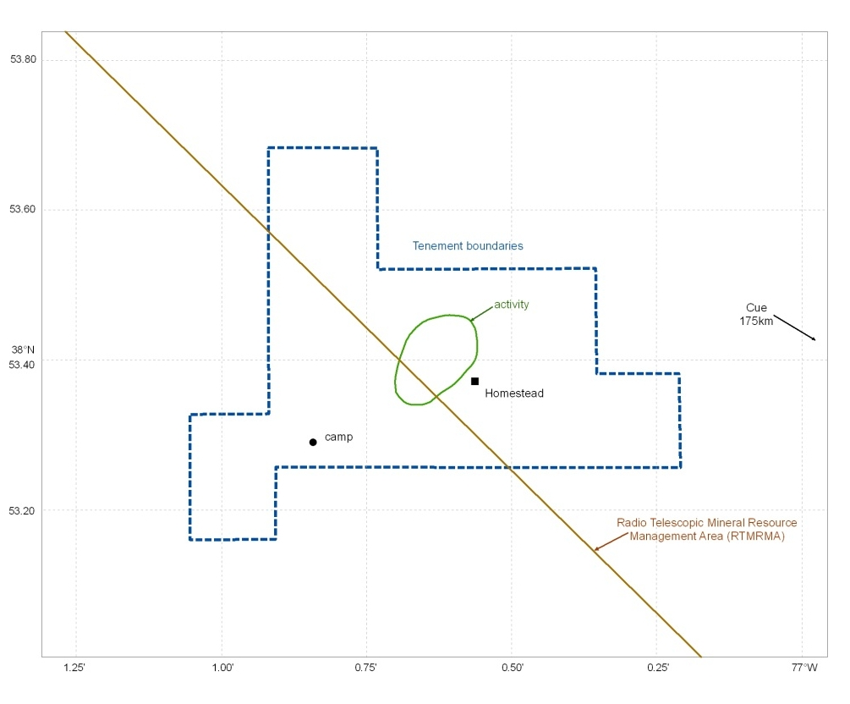
Insert a clearly readable map here showing the tenement(s) and the region of activity and coordinates in either latitude/longitude or easting/northing on the edges of the map.
Radio devices to be used are
Usage patterns of radio equipment should be nominated. Likely time of calling, head office, field suppliers, duration of calls (which must be minimized) and related to the equipment and any other information on the design/brand/model that can be provided.
- [Description of radio, technical specifications as available, and usage patterns. The next dot points provide examples of sufficient detail.]
- [VHF CB radio: 1W handheld radios using ?27MHz, specify type of usage – for example general sporadic communications while on site.]
- [A [Thuraya/Iridium/Globalstar] satellite phone for a 1 minute safety call to base at approximately 7am and 6pm daily and a 15 minute safety and status call at noon. The satellite phone will also be used in the event of any emergency situation.]
Regarding computers, please instruct personnel to switch off wireless modem.
There is no mobile coverage in the region. Therefore, please instruct personnel to switch off all mobile phones, set to flight mode or leave them at a location outside the RTMRMA.
- [Emergency Position-Indicating Radio Beacon activation in an emergency if the satellite phone fails.]
- [Laptop PC with Wi-Fi.]
- [Mobile phones.]

Unintended Radio Emissions
Electrical equipment and vehicles used on site will comply with Australian testing authority electromagnetic compatibility standards. Equipment and vehicles to be used are:
- [Description of equipment and apparatus, technical specifications as available based on predicted or planned apparatus, and anticipated/planned usage patterns. The next dot points provide examples of sufficient detail. If information about compliance with specific standards, for example, CISPR or ANSI standards, as available, please include here.]
- [Diesel trucks. E.g. Two diesel trucks and one 4WD vehicle will be used to transport equipment. Once on site the engines will be turned off.]
- [Diesel-hydraulic drill pump (power rating nn kW). This engine will operate continuously when drilling is under way.]
- [Diesel driven air compressor (power rating nn kW). Will this engine will operate continuously when drilling is under way.]
- [Electric generator (power rating nn kW) and water pump (power rating nn kW). These will operate continuously when drilling is under way.]
- [Any geophysical survey equipment,: IP transmitter/receiver; EM receiver/ transmitter; other electrical property testing apparatus; above-ground electronic apparatus for down-hole surveying; portable XRF equipment; equipment for magnetotellurics or for ground-penetrating radar; anything else utilizing electrical power for any electronic equipment for measure potential or input fields.]
All of this equipment may be in operation from sunrise to sunset during the operational campaign [with electronic/electrical geophysical apparatus, provide details of planned daily/periodic usage. Concepts of nature of transmission etc that may be helpful in determining likely emissions should be provided if known. Provision of co-ordinates of any gridded usage would be helpful.]

Activities
The activities to be covered by this REMP involve [two stages of] work: reconnaissance and drilling. Further activities would be the subject of a future REMP submission.
The specific equipment to be used in the drilling stage cannot be guaranteed until a contractor is chosen by a tender process, but the general type of equipment can be described. If the equipment changes from the list provided in this REMP then the applicant will reapply to DMIRS and the MRO entity will provide advice on the new equipment list.
This paragraph is intended to capture the idea that approvals of the REMP and for the program of work are likely to precede the tender, but that the actual equipment being used needs to be evaluated for RFI.
Prior to any work being undertaken, and as soon as specific dates are known for the stages of work, the MRO site manager (Shaun Amy Shaun.Amy@csiro.au phone 0293-724-452) will be notified. All work approved under this management plan will be completed prior to [date] (the contact person should be confirmed just before the field work notification).
CSIRO has requested three-week’s notice of commencement of field work be provided in order to allow it to prepare/plan/monitor for receiving interference if levels are higher than anticipated.

Reconnaissance Activities
Pre-operational reconnaissance activities will involve [number] people on site, engaged in non-ground disturbing activities. It is expected that they will work onsite for up to [12 hours per day from sunrise to sunset], and would be within the area for periods of [1-2 days, up to 2 weeks] pegging a grid and laying out essential materials to support the exploration program. Other staff may also visit the site but will not use any additional radio or electrical equipment. Staff will camp outside of the RTMRMA, at [location or site name].
Note that if staff are camping inside the RTMRMA, equipment associated with the campsite (vehicles, heaters, generators, microwave ovens etc) must also be described in this REMP.
They will be equipped with the following equipment and will follow the usage patterns and limits described below.
- [laser distance-measuring equipment – provide brands/models likely to be used]
- [VHF CB radio]
- [satellite phone]
- [EPIRB]
- [Laptop PC]
- [Mobile phones]
- [Two diesel trucks]

Drilling Activities
Drilling activities will involve approximately [number] people on site, engaged in ground-disturbing activities. It is expected that they will operate on a basis of 12 hours per day (sunrise to sunset), 7 days per week onsite, for 2 - 4 weeks. Other staff may also visit the site but will not use any additional radio or electrical equipment. Staff will camp outside of the MRMA, at [location or site name].
During the drilling stage, all of the equipment listed will be used in compliance with the usage patterns and limits described there.
The drilling equipment will include
- [Type of drilling rig]
- [Support and service vehicle/s]

Timing of Activities
Following approval of the REMP and related Programme Of Work, the [company] will plan on conducting the field operations as soon as the necessary equipment can be contracted. Optimum period for the activities given usual weather/access limitations is in the period [dd/mm/yy – dd/mm/yy]. However, until the contracts for the field work are signed, there will be no precise timing possible. However [company] will provide the CSIRO manager at least [nn] weeks prior notice before commencing [if the program is to be conducted in stages, please clarify how those will be timed and undertaken].

Contact person(s) for [company]

Name
Position
Postal Address
Phone number(s) including at least a mobile phone contact
Email address

[Alternate contact person should be specified if possible]

[Any other information legally required by the company, for example, statements about OHS compliance, environmental protection, organisational structure, etc, can be added here ,is not required by the MRO entity but may be required in any related POW.]

DMIRS requires sign-off by senior company officer responsible for ensuring activities comply with approved REMP (as with the related POW) and who will be responsible for the company in guaranteeing compliance.

Appendix 1
Boundary of [tenement(s)/activities] covered by this REMP
Tenement [A11/2222] is described by the following points. Coordinates are degrees and decimal degrees of latitude and longitude.
[Note that these coordinates are provided as an example of format. Easting and Northing rather than Latitude and Longitude which may be used alternatively.]
Longitude | Latitude
° East | ° South
77.0153 | 38.8947
77.0122 | 38.8947
77.0122 | 38.892
77.0059 | 38.892
77.0059 | 38.8897
77.0035 | 38.8897
77.0035 | 38.8876
77.0151 | 38.8876
77.0151 | 38.886
77.0176 | 38.886
77.0176 | 38.8888
77.0153 | 38.8888
77.0153 | 38.8947

