CO-FUNDED GOVERNMENT – INDUSTRY ENERGY ANALYSIS PROGRAM
DEPARTMENT OF MINES, INDUSTRY REGULATION and SAFETY,
WESTERN AUSTRALIA

2023−2024 program

Guidelines for Submission of Applications

1. INTRODUCTION 2
2. DEFINITIONS 2
3. APPLICANT ELIGIBILITY 3
4. PROJECT ELIGIBILITY 3
5. SERVICE/ANALYSIS PROVIDER 4
6. FUNDING SPECIFICATIONS 5
7. APPLICATION 5
8. APPLICATION PROCESS 6
9. PROJECT PROPOSAL 6
10. LEGAL PARAMETERS OF PROPOSALS 7
11. POST ANNOUNCEMENT 8
Conditions of acceptance for successful applicants 8
Project modification 9
Withdrawal 9
12. ANALYSIS PROGRAM 9
Deliverables 9
Submission items 10
Specific submission items 10
13. TIMELINE 12
Annexure A. Map showing area of Western Australia state jurisdiction 14
Annexure B. Examples of specific analysis types eligible for funding 15
Annexure C. Final report template 16
Annexure D. Mock invoice 23
Annexure E. Example of analysis provider invoice breakdown costs 24

INTRODUCTION
The Co-funded Energy Analysis Program is an initiative to encourage exploration of petroleum and geothermal resources in the state of Western Australia. It will be a component of the Exploration Incentive Scheme (EIS), which is being funded by the Western Australian State Government and administered by the Department of Mines, Industry Regulation and Safety (Department).
The Co-funded Energy Analysis Program aims to make funding available for analysis of existing state resources (core, sidewall core, cuttings, and oil, condensate, water, and gas samples) and to allow re-analysis of existing data (e.g. reprocessing or desktop studies) to achieve better resolution and understanding of petroleum and geothermal systems. The data from the co-funded projects will become open file to advance exploration activity, address knowledge gaps, and deliver regional information to the wider exploration community.
This Co-funded Energy Analysis Program is separate from the Co-funded Drilling Program. The Co-funded Energy Analysis Program will have a total funding amount of $250,000 per series. Individual refunds will be up to 50% of the analysis costs to a maximum of $50,000 (ex GST).The Co-funded Drilling Program is still available to petroleum or geothermal companies.

DEFINITIONS
“Director General” means the Director General of the Department of Mines, Industry Regulation and Safety.

“Minister” means the Minister for Mines and Petroleum.

“Applicant” means the company, institution or individual submitting a proposal.

“Funding Agreement” means the agreement of conditions of funding grant between the parties. These Guidelines form part of the Funding Agreement.

“Proposal” means the documentation prepared and submitted to the Director General in an application for Government - Industry Co-funded Energy Analysis project.

“Project” means the work undertaken by the successful Applicant in accordance with the Proposal.

“Closing Date” means 4 pm WST on the 1 September 2023. This is the last day to submit a proposal. The online submission of the application must be completed at this time.

“Completion Date” means the date of submission of final report and submission items. This must not be later than 4 pm WST on the 31st October 2024 (finalisation of the project), unless otherwise agreed with the Department.

“Energy Co-funding” means monies distributed to successful applicants on completion of projects.
“Geothermal Title” means the area (or part thereof) outlined in the Proponent’s licence, lease permit, reservation or authority granted under the Petroleum and Geothermal Energy Resources Act 1967 (WA).

“Petroleum Title” means the area (or part thereof) outlined in the Proponent’s licence, lease, permit, reservation or authority granted under the Petroleum and Geothermal Energy Resources Act 1967 (WA) or the Petroleum (Submerged Lands) Act 1982.

“Analysis of physical samples” means analysis conducted on existing rock material either core, sidewall core (SWC), or cuttings, or existing oil, condensate, water or gas samples.
“Pre-existing digital data” means all digital data in any format, including raw data and processed, analysed or interpreted data used or referred to in connection with the project, and includes numerical data, graphic logs, photographs, imagery, photomicrographs and SEM images.

APPLICANT ELIGIBILITY
- The Co-funded Energy Analysis Program is available to fund analysis conducted within the State, including offshore areas within state jurisdiction defined in Annexure A. (Shapefile of state jurisdiction boundary available here.)
- Funding is available for Applicants that hold a Petroleum Title or Geothermal Title or Reservation Title, including a petroleum or geothermal special prospecting authority SPA/GSPA, with or without acreage option (AO)
- Funding is available for applicants that have applied for an exploration permit application STP-EPA, or a special prospecting authority application STP-SPA, (Petroleum or Geothermal).

PROJECT ELIGIBILITY
- Projects proposed must be able to be completed within the 12 month period. If service providers for analytical work are national or international, due consideration must be given to the reliability of businesses to complete and return all data and samples within the 12 month period. Projects eligible for funding would be in one of the following three categories.
- Examples of analysis included within each category is given in Annexure B:
      - Analysis of physical samples
      - Reprocessing
      - Desktop or data studies

- Analysis of physical samples is defined here as; analysis conducted on existing rock material either core, sidewall core (SWC), or cuttings, or existing oil, condensate, water or gas samples.
- Projects with analysis types not specifically listed in Annexure B, but that fall within one of the three categories listed above, are encouraged and would be equally considered for funding.
- If the Applicant proposes to sample a new well, where the material to be analysed has not yet been recovered, the well must have been spudded by the date the application is submitted.
- Analysis types that will not be considered for funding are:
        - Acquisition surveys (e.g. seismic, gravity, magnetic, ground-based geochemical surveys e.g. SNIFFER)
        - Wireline and sampling conducted during operational activities, defined as; any sampling undertaken on a drill site or during drilling activities (e.g. coring, side wall coring, borehole imaging surveys).
- Where required, as part of the assessment process the Department will take into consideration any of following criteria which may impact on the eligibility of the Proposed Program:
        - History in meeting reporting/compliance commitments to the Department
        - Financial and technical capacity of the proponent to complete/undertake the proposed program

SERVICE/ANALYSIS PROVIDER
- The service/analysis provider must provide an invoice to the applicant which shows the analytical costs incurred (see section 6 below for what is not allowable as a cost)
- The service/analysis provider cannot be the applicant, but must be an independent third party with a different name, business address and ABN (or equivalent if outside Australia).
- In the interest of future work, to either reproduce or replicate studies undertaken, it is preferred that the service/analysis provider be a commercial business whose services, or goods (as proposed to be undertaken in an application) can be readily procured by any other companies or individual.
- The service/analysis provider can be an intrastate, interstate or international business.

FUNDING SPECIFICATIONS
- Co-funding is for direct analysis costs only, which does not include: administration costs, shipping costs, project management costs, equipment repair or development, transportation of personnel, or company personnel salaries.
- Individual refunds will be up to 50% of the direct analysis costs up to a maximum of $50,000 (ex GST) per application.
- Subject to where there is funding availability, and in discussion with the advisory panel, DMIRS reserves the right to consult with the successful applicant (after announcement of successful applicants) to discuss the scope of a proposed project. This may occur where the GSWA sees value in expanding the proposed project to acquire additional data. This may have the effect of extending 50% co-funding contribution of the project cost above the offered refund and/or the capped value of $50,000.
- Company invoices (the service/analysis provider) for analysis and reprocessing must be dated within the funding term (1 December 2023 – 30 November 2024) to qualify for the Energy Co-funding.
- If an applicant has withdrawn from the two previous, consecutive Co-funded Energy Analysis series, they will not be eligible to submit an application for a third successive series, but may apply again in later series.

APPLICATION
- Multiple applications from one applicant will be accepted, but second and subsequent applications will be subject to a 5 point handicapping. The strongest application (post assessment) will retain full marks, with the subsequent application scores subject to handicapping.
- Furthermore, for the purposes of applying a handicap, where it is identified that two or more applicants may have different names and ABNs, are in fact related parties, the five point deduction will be applied.
- For the purposes of the co-funding programs, related parties are where:
- There is a parent company with the same name, business address and ABN, and/or
- The registered business address is the same on the applications, and/or
- Proposed projects in the applications are located on the same entity/parent home website.

- The same Petroleum or Geothermal Title, SPA/SPA (AO), or STP-SPA number may be cited for all applications submitted in a multiple application scenario.
- The project scope must be clearly and significantly different for each application submitted in a multiple application scenario.
- The Applicant may propose to undertake different types of analysis under the scope of one Project (e.g. biostratigraphic analysis and petrophysical analysis). However, the refund is still capped at $50,000 (ex GST) for 50% of actual costs for a single application.
- A proposed project may be a combination of the three categories listed above (e.g. include both analysis of physical samples, and a desktop or data study component).

APPLICATION PROCESS
The application form will have three sections. Section three, Project Criteria, will ask for technical details of the proposed project.
To distinguish one application from another the Project Criteria section will have three sections a) Scientific Concepts, and b) and c) Sampling Specifics.

Section A – Scientific Concepts will be scored out of 100 points, and marks will be allocated according to a marking guide. The number of points assigned to each question will be shown on the application form, but the marking guide will not be made available to the Applicant.
Section B and C – Sampling Specifics of the application will not be scored. These questions will not relate to all projects proposed. If a question does not relate to the Applicants’ project the Applicant should select the option 'not applicable'. The details given in this section will be considered only in relation to projects where they are relevant.
Applications will be assessed by external non-government representative with relevant experience, but may also include Department representatives with relevant knowledge.

PROJECT PROPOSAL
The project proposal should be clear and concise, and images or maps included must be clear and legible.
A suitably detailed analysis plan appropriate for the type of analysis proposed must be provided.
- For analysis of physical samples this must include details of: well or wells to be sampled, type of analysis, type of samples (core, sidewall core, cuttings, oil, condensate, water or gas), target lithologies, approximate depth or depth range of samples to be taken, and details of existing samples and analysis that has been undertaken and are relevant to the project.
- For reprocessing projects this must include:
- A map showing the distribution of all seismic lines and wells in the project area, including those to be reprocessed. Well-ties to be used should be indicated, as should the availability of well velocity data.
- Example seismic line(s) showing the specific issues with the existing data (e.g. multiples, statics, vintage mis-ties, poor fault, fold or horizon imaging.) Brief summary of reprocessing method (if known) and how it will improve imaging.
- A table of all basic seismic information in the area including; date acquired, fold, last known reprocessing information is preferable.
- Details of the existing data to be reprocessed; is the original data/tapes available, readable, or is this not known?
- For desktop and data study projects this must include details of: well or wells and/or geophysical lines to be included in the study, type of data to be analysed and the source of those samples (e.g. core, sidewall core, cuttings, oil, condensate, water or gas), including number of samples and depth or depth range of samples.
Relevant supporting data (e.g. correlation panels, seismic images, well logs, data tables) that help define the necessity of the proposed project should be included.

LEGAL PARAMETERS OF PROPOSALS
- Subject to Item 9(b) below, contents of all Proposals will remain confidential, except for the Name of the Applicant and the general type of study they have applied to complete, (e.g. reservoir analysis, seismic reprocessing, depth to basement modelling).

- Although the Director General understands the need to keep commercial matters confidential in appropriate circumstances, the Director General reserves the right to disclose some or all of the contents of the Proposal so that the relevant Minister may answer questions raised in the Western Australian Parliament, keep Parliament informed or otherwise discharge the Minister’s duties and obligations to Parliament and to advise the Governor, Parliament and/or the Western Australian Government. Any condition in a Proposal that purports to prohibit or restrict the Minister’s right to make such disclosures cannot be accepted.

- Reservation of Rights - the Department reserves the right to:

  - Amend the Proposal closing date;
  - Amend the Conditions For Proposals at any time prior to the Closing Date for Proposals provided that the amendment is notified to prospective Proponents;
  - Clarify any aspect of a Proposal after the Closing Date for Proposals but before the endorsement of successful applicants by the by independent industry representatives (EIS Advisory committee);
  - Seek the advice of the Department personnel and external consultants to assist the Director General in evaluation or review of Proposals; and
  - Abandon the process whether before or after the receipt of Proposals.

d) The Director General is not obliged to give any reasons for its selection or the abandonment of this process.

e) The Director General is not obliged to accept any Proposal.

f) No acceptance of a Proposal will be effective to constitute a contract or to create any legitimate expectation on the part of the Applicant unless a formal written agreement is executed by both parties.

g) Prior to accepting a Proposal the Director General may request additional information, including but not limited to, evidence of financial capacity.

h) The Director General, when considering a Proposal will expect that the following criteria are satisfied:

- The Applicant and proposed service providers possesses the necessary skills, knowledge and experience to comply with the Conditions For Proposals and undertake the proposed Energy Analysis Project
- The Applicant is fully informed of all facts and conditions of all things relating to the Guidelines for Submission of Applications.

i) Applicants are responsible for the cost of preparing and submitting their Proposal and all other costs arising out of the process.

j) Closing date for Application submission is Friday 1 September 2023 at 4.00 pm WST.

POST ANNOUNCEMENT

Conditions of acceptance for successful applicants
All successful Applicants will be required to enter into a Funding Agreement with the State of Western Australia acting through the Department.

The following principles will apply to management of funding for successful Applicants:
- Management of the successfully funded Projects will be undertaken by the Project Applicants and/or operational nominees. All liabilities associated with the Project remain with the Project Applicants. No allowance will be made for delayed projects.
- Where total analysis costs for a completed Project are less than the estimate in the Proposal, the Department will provide funding in proportion to the ratio of the funding requested and the estimated total cost. An invoice or tax invoice from the Applicant, together with a concise summary of total analysis costs (including copies of tax invoices from analysis contractors/providers) must be provided to the Director General.
- Analysis must be undertaken by a third party, whereby submitted analysis providers invoices show a different company name, business address, and ABN from the successful applicant awarded the EIS co-funded drilling.

Project modification
Should the Applicant have significant modifications to the project proposal once the Funding Agreement has been awarded, they should contact the EIS coordinator to advise the specifics of and the reasons for the modifications. The EIS coordinator will then contact the Applicant with a decision regarding if the proposed modifications are still acceptable to the signed agreement.
If there is a delay in sample submission due to extenuating circumstances, the Applicant must contact the EIS coordinator prior to the submission deadline of 31 October 2024.

Withdrawal
Should the Applicant wish to withdraw from the Funding Agreement they must notify the EIS coordinator in writing before the submission date (31 October 2024).
Withdrawal from the Funding Agreement will not affect the scoring of a future application for the Co-funded Energy Analysis Program by the Applicant.
If an applicant withdraws from two consecutive Co-funded Energy Analysis Program series, they will be ineligible to apply for the third consecutive series, but may apply again in later series applications.

ANALYSIS PROGRAM
For analysis of physical samples in projects conducted on the Department material, sampling approval must be gained via the normal Department process, and all samples collected must comply with the sampling regulations outlined.
http://www.dmp.wa.gov.au/Geological-Survey/Core-library-services-and-1391.aspx
Applicants should clearly state in their email requesting sampling approval from the Department that analysis is being undertaken as part of an EIS Co-funded Energy Analysis Project.
Applicants should check their proposed sample locations carefully. In cases where insufficient material is present due to previous sampling or poor recovery, or where the same type of analysis has already been undertaken at the proposed location, a sampling application may be declined.

Deliverables
All deliverable data must be provided in the standard data formats for reporting results from petroleum titles or geothermal titles as required by the Department.
http://www.dmp.wa.gov.au/Petroleum/Petroleum-and-Geothermal-data-1574.aspx
Analysis results, physical samples, and analysis products required under the standard the Department sampling agreement should be returned to the Department as a single submission as part of the Co-Funded Energy Analysis Program final submission, along with the other Submission Items listed below.
For all projects the raw digital data, processed digital data, final report, and invoices should be electronically submitted where possible.
On completion of the project, the following items are required for submission to the Department.

Submission items
- Final Report, completed as per the template in Annexure C.
- Raw digital data of all analysis undertaken.
- Processed digital data of all work undertaken.
- All physical samples and analysis products (e.g. core plugs, thin sections, biostratigraphic slides and residues, radiometric dating mounts, leftover cuttings, plugged core).
- The Applicant’s company tax invoice for re-imbursement specifying the amounts for different analysis types if relevant, see example given in Annexure D.
- Analysis provider’s tax invoice/s – this must show an itemised breakdown of sample preparation and analysis costs excluding GST, see Annexure E for example of item breakdown.

Specific submission items
- The file format and requirements for data submission should conform to the RMAR 2015 guidelines https://www.dmp.wa.gov.au/Documents/Petroleum/PD-SBD-ADM-180D.pdf (see section 4.8 RMAR Part 8 – Data Management).
- Seismic reprocessing projects must include velocity data, processing reports, and newly processed SEG-Y files in the final data submission.
- Where biostratigraphic sampling is undertaken, both slides and residues must be submitted.
- Where desktop or data studies are undertaken, the data input (e.g. pre-existing digital data) should be provided as ‘raw data’ (i.e. a list of data points/samples and the results used for re-analysis or re-interpretation).
- For analysis of physical samples, all sample products and remnant core, sidewall core, and cuttings material (e.g. petrographic slides and residues, core stubs, core plugs and plugged sections) must be returned to the Department.
- Remnant samples (e.g. core plugs, core that has been plugged, remaining cuttings) should be delivered to the Perth Core Library:
Core Librarian
Perth Core Library
37 Harris St
CARLISLE, WA 6101
corelibrary.submissions@dmirs.wa.gov.au

- Final reports, raw digital and/or processed data, invoices and a document/item manifest and portable hard drives, tape cartridges, and any analysed physical sample products such as thin sections, residues, and mounts should be emailed and delivered to:
Statutory Exploration and Information Group – Petroleum
Department of Mines, Industry Regulation and Safety
1st Floor North, 100 Plain Street
EAST PERTH WA 6004
petdata@dmirs.wa.gov.au

The submission email subject line should have the format:
EIS EAP (company name) Series (x) (unique EAP number) Permit Number (EPXXX)
e.g. for a submission in funding Series 6:
EIS EAP Australian Energy Company Pty Ltd Series 6 EAP2022S5/0001 EP000

Submissions delivered to the Perth Core Library and the Statutory Exploration and Information Group – Petroleum should also contain a label in this format.

The unique EAP number will be generated at the time of application.

- A copy of the emailed submission and attachments should also be sent to:
Ms Louisa Collins
Department of Mines, Industry Regulation and Safety
100 Plain Street
EAST PERTH, WA 6004
Louisa.COLLINS@dmirs.wa.gov.au
Phone: +61 8 9222 3768
- and cc’d to:
Dr Charlotte Hall
Coordinator Exploration Incentive Scheme
Department of Mines, Industry Regulation and Safety
100 Plain Street
EAST PERTH, WA 6004
Charlotte.HALL@dmirs.wa.gov.au
Phone: +61 8 9222 3410

TIMELINE
7 August 2023 | Online applications open
1 September 2023 | Online applications close (4 pm WST)
Mid-late October 2023 | Planned announcement of successful Proposals
By 30 November 2023 | Agreements signed by Applicants and the Department and fully executed agreement returned to the Department
1 December 2023 – 30 November 2024 | Term of Funding Agreement for 2023−2024 Co-funded Analysis
31 October 2024 | Completion Date for submission of final reports, raw digital data, physical samples, and invoices for 2023−2024 analysis projects (4 pm WST)
30 November 2024 | Last date for acceptance of amended final reports by the Department
1 March 2025 | All data released to open file

- Projects may be completed at any time within the Funding Term (1 December 2023 to 30 November 2024) with lodgement of all submission items and the final report accepted by the Department.
- Analysis must be completed and all submission items must be submitted by 31 October 2024.
- Payment of invoices pertaining to the refund will occur within 20 days following lodgement of submission items and acceptance of the final report by the Department.
- If the final report submitted at or before 31 October 2024 is incomplete or submission items are outstanding (missing), the Applicant will be contacted and final amendments specified by the Department will be requested. The amended final report and any outstanding submission items must be submitted and approved by the Department by 30 November 2024.
- If the final report is not accepted or submission items are missing by the due dates, the refund payment is no longer valid.
- The final report for the Applicant’s project must be approved by the Department no later than 30 November 2024.
- Confidentiality will end on the 28 February 2025, regardless of the date that the data and report are submitted to the Department during the Funding Term.

Department |  |  |  | APPLICANT
Co-funded analysis scheme applications open |  | 7 August 2023
 |  |  |  | Application prepared
Assess Applications |  | Submit by 1 September 2023
Announce successful applications |  | Mid –Late October 2023
Agreements prepared, signed by the Department, and sent to applicants |  | Early November 2023
 |  | By 30 November 2023 |  | Agreement signed by Applicants and returned to the Department
 |  | 1 December 2023 |  | Commencement of analysis
Assess final report and invoice |  | Submit at any date within the Funding Term before 31 October 2024 |  | Submission of digital raw data, physical products, final report, company tax invoice and analysis provider’s invoice.
Satisfactory
Approve payment of invoice within 20 days of submission
Unsatisfactory
Return final report for amendments.
Request missing submission items.
Assess final report and final invoice |  | Submit no later than 30 November 2024 |  | Revise final report.  Lodge outstanding submission items.
Satisfactory
Approve payment of invoice within 20 days of submission
Release data to Open File |  | Release date 1 March 2025

Annexure A. Map showing area of Western Australia state jurisdiction
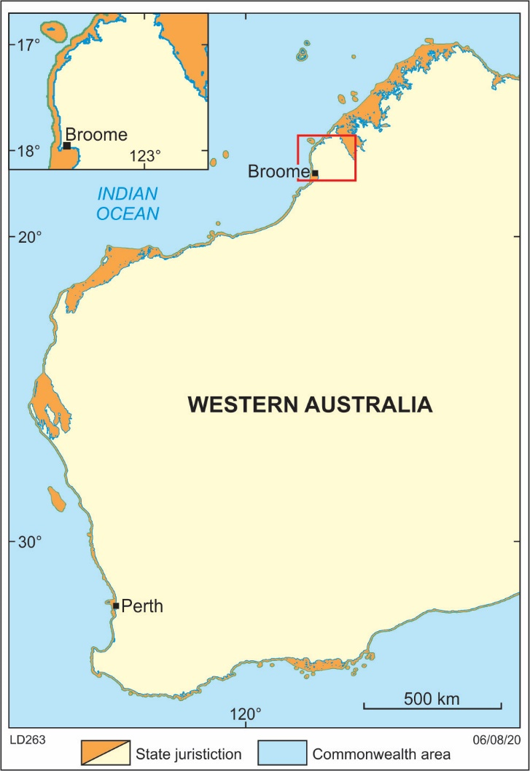

Annexure B. Examples of specific analysis types eligible for funding. Analysis types not specifically listed below, but that fall within one of the three categories are encouraged and will be equally considered for funding.

ANALYSIS OF PHYSICAL SAMPLES | REPROCESSING | DESKTOP OR DATA STUDIES
BIOSTRATIGRAPHIC ANALYSIS  Microfossil analysis (palynology, conodont, foram, dinocyst etc.)  Macrofossil analysis  Ichnological analysis  RADIOMETRIC DATING  Zircon (detrital and crystallisation ages)  Apatite fission track (AFTA)  Xenotime  Re/Os shale dating  Techniques may include (TIMS including CA-IDTIMS, SIMS including SHRIMP, LA-ICPMS and Nobel Gas Mass Spectrometry)  INORGANIC GEOCHEMICAL ANALYSIS  Elemental analysis/mineral mapping (XRD, XRF, MEG, ICP-MS)  Chemostratigraphy  Stable isotope analysis  Fourier Transform Infrared Spectroscopy (FTIR)  Spectral imaging and photography (e.g. HyLogger analysis)  Core gamma  ORGANIC GEOCHEMICAL ANALYSIS  TOC-RE  Gas Chromatography Mass-Spectrometry (GC-MS)  Gas analysis (headspace, desorption)  Extractable organic matter analysis  Fluid inclusion stratigraphy  Kerogen kinetics  Maturity analysis (VR, CAI, TAI)  PETROGRAPHIC ANALYSIS  Thin sections  Scanning electron microscopy (SEM, ArSEM)  Cathodoluminescence analysis  Acetate peels  Polished sections  PETROPHYSICAL ANALYSIS  Porosity and permeability (routine RCA, tight rock TRA, mercury injection MICP, special SCAL)  Rock mechanics (ultrasonic velocity, triaxial compressive test, brazilian tensile strength, Mohr-coulomb failure analysis)  Adsorption isotherm  Desorption capacity  Computer tomography (CT) scans | Seismic  Gravity  Magnetotelluric  Radiometric  Airborne magnetics  Ground-based magnetics | Borehole image interpretation  Depth to Basement e.g SEEBASE  Inferred basement heat flow  Biostratigraphic reassessment from old slides  Petrophysical re-analysis  Cyclostratigraphy

Annexure C. Final report template

EAP Series 6 2023−2024

EIS Co-Funded Energy Analysis Program
FINAL REPORT

PROJECT TITLE
Company (Applicant) name:
Applicant ID EAP Number:

Contents

Executive Summary 21
Project Details 22
Project Summary 23
Item Manifest 24

Executive Summary

Project Details

Project Title: (xxxxxx xxxxxxxx)
Applicant: (company or individual)
Unique EAP Number (Application ID): EAPXXXXSX/XXXXXXXX
Exploration/target commodity: Petroleum, geothermal, in situ-CO₂, Hydrogen, Helium.
Project Completion Date: XX/XX/XXXX
Permit Number: (EPXXX / SPAXXX / SPA(AO)XXX / STP-SPAXXX)
Sampling Approval Number: (GXXXXXX – if THE DEPARTMENT material was sampled)

Project Location: Please provide a regional description and insert a location map/s which displays regional and specific location context for the project. Include relevant wells or seismic lines. Maps should include a scale, latitudes and longitudes.

Project Summary
Prepared by: XXXXX

- Provide a summary of your project including details of study area, analysis undertaken, and the main objective of your project.

- Discuss the key findings from your analysis, include maps, figures, correlation panels, or tables as appropriate. Discuss the application of these findings to the project objective/s.

- How did this work significantly add to the existing knowledge of the area?

- How will the findings and data generated from this analysis program enhance energy exploration in the sedimentary basin?

Item Manifest

Please list all documents and items included in your submission to the Department in the table below (delete unused columns).
Item number | Submission item | Document/item name | Submission method
1. | Analysis provider’s invoice |  | Electronic
2. | Applicant’s invoice |  | Electronic
3. | Raw digital data |  | Electronic
4. | Thin sections |  | Delivery
5. | Core stubs |  | Delivery
6.
7.
8.
9.
10.

Submissions
(please delete this page from your Final Report)
SUBMISSION CHECKLIST:
Final Report (this report)
Applicant’s company invoice/tax invoice
Analysis provider’s tax invoice/s
Raw data files
Processed data files (for seismic reprocessing)
Analysis products (e.g. thin sections, geochronology mounts, residues)
Remnant samples (e.g. plugged core pieces, core plugs, remnant cuttings)

Final submissions should be emailed to petdata@dmirs.wa.gov.au, and cc’d to charlotte.hall@dmirs.wa.gov.au

Please format the SUBJECT line in your email submission as:
EIS EAP (company name) Series (X) (unique EAP number) (permit number)
e.g. EIS EAP Australian Energy Company Pty Ltd Series 6 EAP0000 EP000

Physical data items (e.g. hard drives and tapes), and analysis products (e.g. thin sections, geochronology mounts, residues) should be delivered to:
Statutory Exploration and Information Group – Petroleum
Mineral House
100 Plain Street
East Perth, 6004
Western Australia
Remnant samples (e.g. plugged core pieces, core plugs, remnant cuttings) should be delivered to:
Perth Core Library
37 Harris Street
Carlisle, 6101
Western Australia

Annexure D. Mock invoice

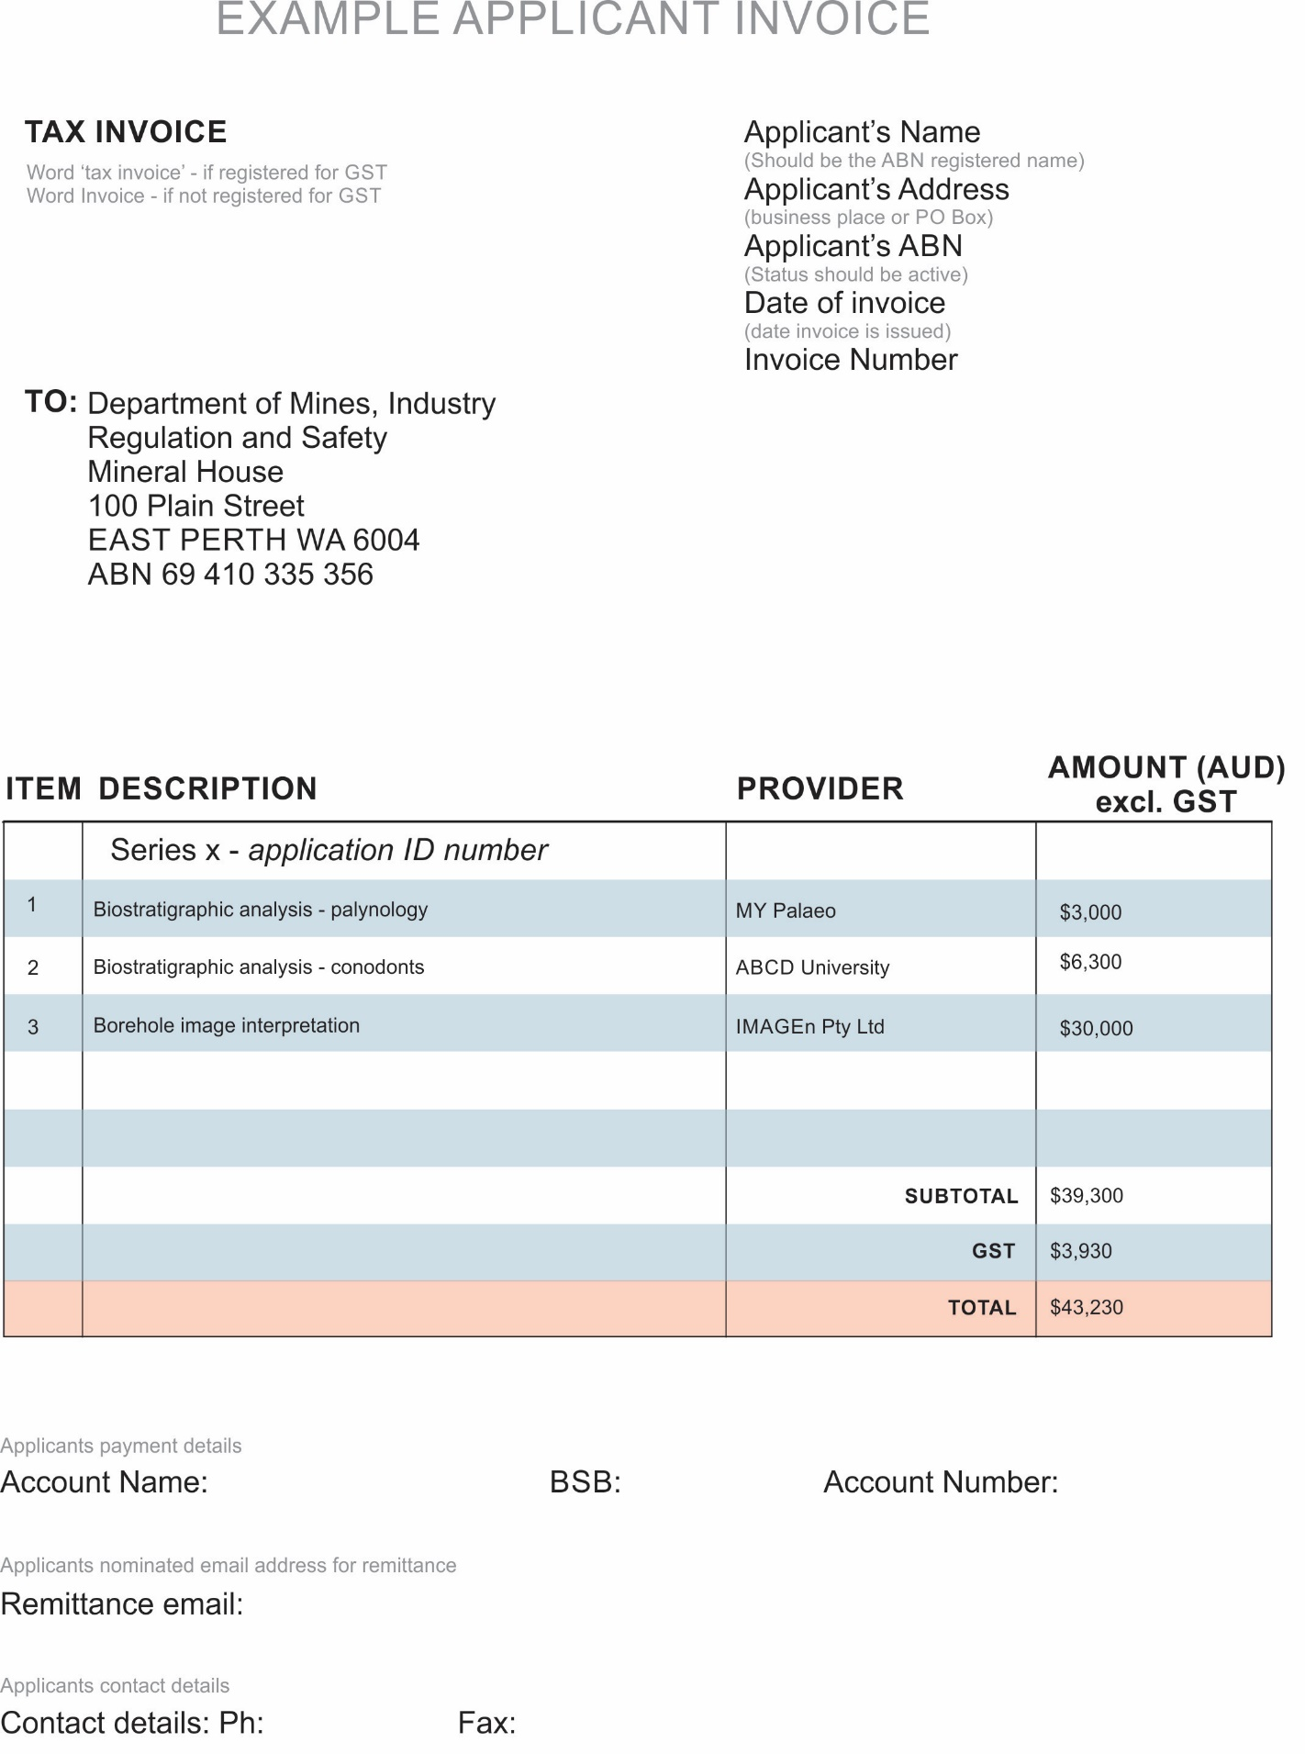

Annexure E. Example of analysis provider invoice breakdown costs
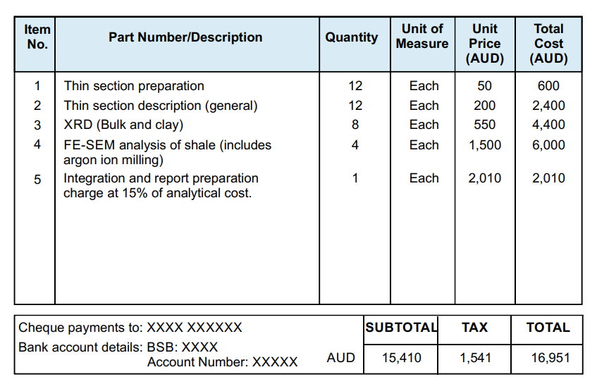

If the Applicant has an ABN but is not registered for GST they submit an invoice. If the Applicant has an ABN and is registered for GST they submit a tax invoice and the GST component must be shown on the invoice.

