Area T19-2

Release Summary
Petroleum Acreage Release 1 of 2019 – Area T19-2
Released: Tuesday 10 December 2019
Closed: Thursday 9 April 2020
Areas available: Petroleum (Submerged Lands) Act 1982
Area: T19-2
Graticular blocks:

1:1,000,000 Perth Map Sheet (SH50)

Block No | Block No | Block No | Block No | Block No
5873 | 5874 | 5946 | 5947

Contains four blocks to the extent only that the area is within the State as defined in section 5 of the PSLA82

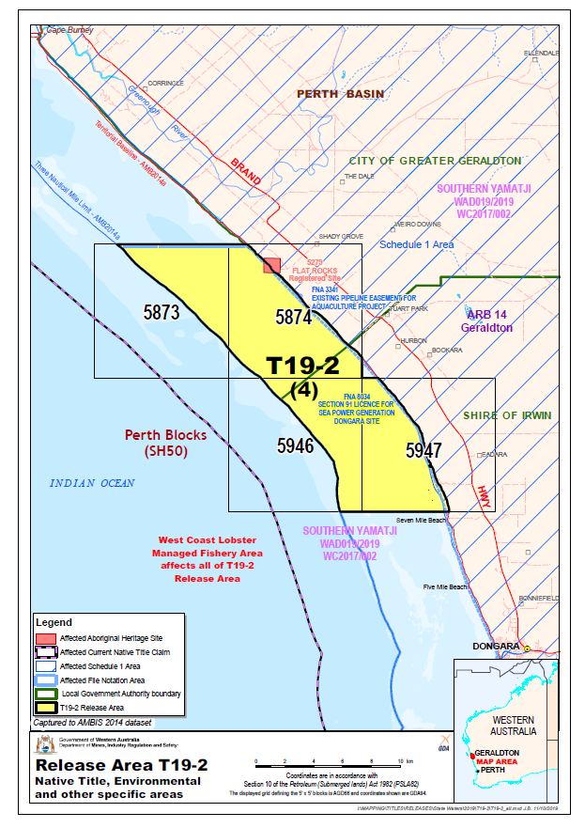

Environmental considerations
Maritime area overlaps several biologically important areas and is directly adjacent to key ecological features in Commonwealth waters. Operational activities may require referral to the Environmental Protection Authority and consultation with the Department of Biodiversity, Conservation and Attractions and the Department of Primary Industries and Regional Development. For operational activities that have the potential to impact Commonwealth environmental interests, consultation with the Department of Environment and Energy (Cth) will be required. See map provided.

Available data and maps
- Area L19-2 Map
- Area L19-2 Area shapefile
- Area L19-2 Seismic lines and wells map
- 2D Seismic lines
- 3D Seismic polygons
- Aeromagnetic and Gravity surveys
- Area L19-2 Data listing
- Order forms for available data

Contact
For any general enquiries please contact the Resource Tenure team
Email: petroleum.titles@dmirs.wa.gov.au

For data enquiries please contact the Statutory and Resource Information team
Email: petdata@dmirs.wa.gov.au

