Combined L19-1/T19-1

Area Summary

Petroleum Acreage Release 1 of 2019 – Combined Area L19-1/T19-1
Released: Tuesday 10 December 2019
Closed: Thursday 9 April 2020
Areas available: Combined area under Petroleum and Geothermal Energy Resources Act 1967 (PGERA) and Petroleum (Submerged Lands) Act 1982 (PSLA)
Area: L19-1
Graticular blocks:
1:1,000,000 Hamersley Range Map Sheet (SF50)
Block No | Block No | Block No | Block No | Block No
5881 | 5880 | 5879 | 5950 | 6021
6093 | 6092 | 6164

Contains eight blocks to the extent only that the area is within the State as defined in section 26 of the PGERA67.
Area: T19-1
Graticular blocks:
1:1,000,000 Hamersley Range Map Sheet (SF50)
Block No | Block No | Block No | Block No | Block No
5880T | 5807T | 5879T | 5878T | 5950T
5949T | 6021T | 6020T | 6093T | 6092T
6091T | 6164T

Contains 12 blocks to the extent only that the area is within the State as defined in section 5 of the PSLA82.

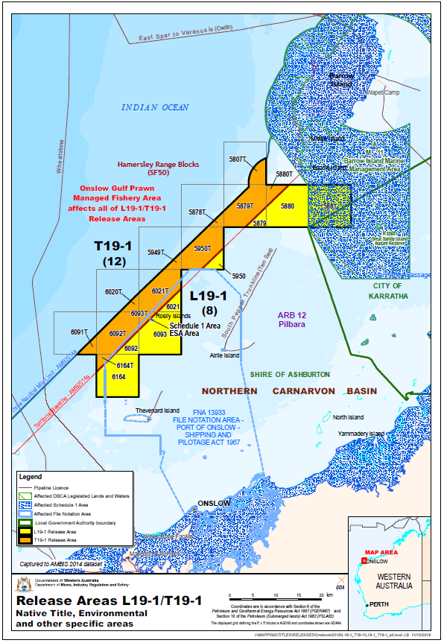
A combined application, proposing a unified work program, is necessary and is achievable as part of this release via the Department’s PGR online system. Two prescribed application fees are payable (one under each legislation) as stated in the schedule of fees and are non-refundable and subject to variation.
While two permits will be issued to the successful applicant, those permits will, as far as the legislation allows, be dealt with as one and work undertaken in one permit will count as undertaken in the other permit.

Special Notices
Applicants should be aware of the following special notices in relation to Area L19-1:
- I, Richard John Rogerson, Executive Director, Resource Tenure Division of Department Mines, Industry Regulation and Safety, under delegation from the Minister for Mines and Petroleum, pursuant to section 30(2) of the Petroleum and Geothermal Energy Resources Act 1967, hereby direct that subsection (3) of section 31 does not apply to or in relation to applications for Area L19-1.
- It is intended that a condition under section 91B of the Petroleum and Geothermal Energy Resources Act 1967 will apply to any petroleum exploration permit granted in respect of Areas L19-1 prohibiting the holder from entering upon:
  - any land, including islands, above the mean low water mark as is included in the permit area.
  - Crown reserves R33831 Great Sandy Island Nature Reserve, R44667, and R44668 North Sandy Island Nature Reserve.
Applicants should be aware of the following special notices in relation to Area T19-1:
- It is intended that a condition under section 33 of the Petroleum (Submerged Lands) Act 1982 will apply to any petroleum exploration permit granted in respect of Area T19-1 prohibiting the holder from entering upon any land, including islands, above the low water mark as is included in the permit area.

Environmental considerations
Maritime area partially within Barrow Island Marine Management Area (north east blocks). The coastal waters of the Pilbara Region support a diverse array of marine life and are also recognised as biologically important areas for a number of protected species. Operational activities may require referral to the Environmental Protection Authority and consultation with the Department of Biodiversity, Conservation and Attractions, and for operational activities that have the potential to impact Commonwealth environmental interests, consultation with the Department of Environment and Energy (Cth) will be required. See map provided.

Available data and maps
- Area L19-1/T19-1 Map
- Area L19-1/T19-1 Area shapefile
- Area L19-1/T19-1 Seismic lines and wells map
- 2D Seismic lines
- 3D Seismic polygons
- Aeromagnetic and Gravity surveys
- Wells_L19_1_and_T19_1
- Area L19-1/T19-1 Data listing
- Order forms for available data

Contact
For any general enquiries please contact the Resource Tenure team
Email: petroleum.titles@dmirs.wa.gov.au

For data enquiries please contact the Statutory and Resource Information team
Email: petdata@dmirs.wa.gov.au

