Managing electrical risks in the workplace
Code of Practice

Disclaimer
The information contained in this publication is provided in good faith and believed to be reliable and accurate at the time of publication. However, the information is provided on the basis that the reader will be solely responsible for assessing the information and its veracity and usefulness.
The State shall in no way be liable, in negligence or howsoever, for any loss sustained or incurred by anyone relying on the information, even if such information is or turns out to be wrong, incomplete, out-of-date or misleading.
In this disclaimer:
State means the State of Western Australia and includes every Minister, agent, agency, department, statutory body corporate and instrumentality thereof and each employee or agent of any of them.
Information includes information, data, representations, advice, statements and opinions, expressly or implied set out in this publication.
Loss includes loss, damage, liability, cost, expense, illness and injury (including death).

Reference
Work Health and Safety Commission, Managing electrical risks in the workplace: Code of practice, Department of Mines, Industry Regulation and Safety XXpp.
ISBN XXXXXXXXXXX (web)
© State of Western Australia (Department of Mines, Industry Regulation and Safety) XXXX This publication is available on request in other formats for people with special needs.
Further details of work health and safety publications can be obtained by contacting:
WorkSafe Group – Regulatory Support
303 Sevenoaks Street
CANNINGTON WA 6107
Telephone: 1300 307 877
NRS: 13 36 77
Email: SafetyComms@dmirs.wa.gov.au

Further details of electrical licensing publications can be obtained by contacting:
Building and Energy
303 Sevenoaks Street
CANNINGTON WA 6107
Telephone: 1300 489 099
NRS: 13 36 77
Email: be.info@dmirs.wa.gov.au

Contents
Foreword 5
Introduction 6
1.1. What are electrical risks? 6
1.2. Electrical work? 6
1.3. Who has health and safety duties in relation to electrical risks? 7
1.4. What is involved in managing electrical risks at the workplace? 10
The risk management process 14
1.5. Identifying the hazards 14
1.6. Assessing the risks 15
1.7. Controlling the risks 17
1.8. Maintaining and reviewing control measures 18
Specific hazards and control measures 20
1.9. Underground electric lines and cables 20
1.10. Overhead electric lines 21
1.11. Unsafe electrical equipment and electrical installations at the workplace 21
1.12. Inspecting and testing electrical equipment 22
1.13. Inspecting and testing equipment—construction and demolition sites 26
1.14. Residual current devices 26
Work in roof spaces 33
Working de-energised 35
1.15. General principles—verification of de-energised electrical equipment 35
1.16. Work on or near electrical cables (including cutting cables) 36
Isolation, locking off and access 37
1.17. Securing the isolation 37
1.18. Restoring power 43
1.19. Leaving unfinished work 43
Working on or near energised electrical installations 44
1.20. Electrical work on or near energised electrical installations 44
1.21. Safe work method statements 47
1.22. Hierarchy of control measures 50
Tools and equipment 52
1.23. Maintenance and inspection 52
1.24. Ladders, scaffolds and similar equipment 52
1.25. Insulating barriers and insulating mats 53
1.26. Test instruments 53
1.27. Personal protective equipment 54
1.28. First Aid 54
High voltage electrical work 56
1.29. Additional risks associated with high voltage 56
1.30. Planning for high voltage installation work 56
Electricity in mines 57
1.31. Managing electrical risks in mines 57
1.32. Records to be kept 58
1.33. Electrical log books 58
1.34. Earthing systems 59
1.35. Trailing cables and reeling cables 59
1.36. Earthing continuity protection and monitoring 60
1.37. Mine safety management system 60
Appendix 1—Glossary 63
Appendix 2—Advantages and disadvantages of non-portable and portable RCDs 68
Non-portable RCDs 68
Non-portable RCDs installed at the main switchboard 68
Non-portable RCDs installed at a socket outlet 68
Portable RCDs 69
Portable RCDs—portable plug type 70
Portable RCDs—portable stand-alone unit 70
Appendix 3 – Electricity safety checklist 71
Appendix 4 – Resources and additional information 73
Appendix 5 – Reporting an electrical incident 74

Foreword
Scope and application
This Code of practice is intended to be read by a person conducting a business or undertaking (PCBU). It provides practical guidance to PCBUs on managing electrical risks in the workplace. It applies to all workplaces where a PCBU has management or control of electrical equipment, including electrical installations. While this Code provides general guidance and will assist a PCBU in meeting their obligations under the WHS Act, electrical work is covered under the ELR and regulated by Building and Energy. Any PCBU or worker conducting electrical work must comply with the requirements of the ELR and guidance material developed by Building and Energy.
This Code may be a useful reference for other persons interested in the duties under the WHS Act and WHS Regulations.
This Code applies to construction and demolition sites, except if a requirement of the Code is dealt with in AS/NZS 3012:2010: Electrical installations – Construction and demolition sites. In that case you must comply with AS/NZS 3012:2010 Further information about construction work can be found in the Code of Practice: Construction work.
This Code does not apply to:
- electrical work on extra-low voltage electrical equipment, including extra-low voltage electrical installations
- electrical work on high voltage equipment after switching, isolation, short circuiting and earthing, subject to summary guidance in Chapter 9 of this Code
- the manufacture of electrical equipment
- automotive electrical work
- work that is not electrical work carried out on telephone, communication and data systems
- work carried out by or on behalf of an electricity supply authority on the electrical equipment controlled or operated by the authority to generate, transform, transmit or supply electricity
- repair of consumer electrical equipment when unplugged from any electrical socket outlet.
‘Extra-low voltage’ means voltage that does not exceed 50 volts alternating current (50 V a.c.) or 120 volts ripple-free direct current (120 V ripple free d.c.).
How to use this Code of Practice
This Code includes references to the legal requirements under the WHS Act and WHS Regulations. These are included for convenience only and should not be relied on in place of the full text of the WHS Act or WHS Regulations. The words ‘must’, ‘requires’ or ‘mandatory’ indicate a legal requirement exists that must be complied with.
The word ‘should’ is used in this Code to indicate a recommended course of action, while ‘may’ is used to indicate an optional course of action.

Introduction

What are electrical risks?
Electrical risks are risks of death, shock or other injury caused directly or indirectly by electricity. The most common electrical risks and causes of injury are:
- electric shock causing injury or death. The electric shock may be received by direct or indirect contact, tracking through or across a medium, or by arcing. For example, electric shock may result from indirect contact where a conductive part that is not normally energised (such as a metal toaster body or a fence) becomes energised due to a fault
- fire (such as fire resulting from an electrical fault), arcing or explosion causing burns. These injuries are often suffered because arcing or explosion or both occur when high fault currents are present
- electric shock from ‘step-and-touch’ potentials
- toxic gases causing illness or death. Burning and arcing associated with electrical equipment may release various gases and contaminants.
Even the briefest contact with electricity at 50 volts for alternating current (V a.c.) or 120 volts for direct current (V d.c.) can have serious consequences for a person’s health and safety. High voltage shocks (involving more than 1000 V a.c. or 1500 V d.c.) can cause contact burns and damage to internal organs.
Electric shocks may also lead to other injuries, including falls from ladders, scaffolds or other elevated work platforms. Other injuries or illnesses may include muscle spasms, palpitations, nausea, vomiting, collapse and unconsciousness.
Workers using electricity may not be the only ones at risk—faulty electrical equipment and poor electrical installations can lead to fires that may also cause death or injury to others.

Electrical work?
ELR r. 4A
Term used: electrical work
ELR r. 19
Electrical work prohibited unless authorised
WHS General Regulations r. 146
WHS Mines Regulations r. 146
Meaning of electrical work
Electrical work must be carried out in accordance with the Electricity (Licensing) Regulations 1991 (ELR). For more information contact Building and Energy. This code does not outline the requirements of electrical work, but is written as a general guide to assist PCBUs and workers to understand their obligations under the WHS Act.

What is electrical work
Electrical work means work:
- where electricity is supplied, or intended to be supplied, at voltage exceeding 50 V a.c. or 120 V d.c. on:
  - electrical machines or instruments
  - an electrical installation
  - electrical appliances or equipment
- comprising an assessment of an electrical installation to ensure that the installation, and any work done on the installation, complies with the requirements of the ELR.
Exemptions are outlined in regulation 19 of the ELR.

Electrical licensing laws
Western Australian electrical licensing laws are outlined in the ELR.
For more information about the applicable electrical licensing or registration laws contact Building and Energy.

Who has health and safety duties in relation to electrical risks?
There are a number of duty holders who have a role in managing electrical risks. These include:
- persons conducting a business or undertaking (PCBUs)
- designers, manufacturers, importers and suppliers of plant, substances or structures
- officers
- workers, including electrical workers, electricians and electrical contractors.
Workers and other persons at the workplace also have duties under the WHS Act, such as the duty to take reasonable care for their own health and safety at the workplace.
WHS service providers have a duty to ensure that their WHS service does not put persons at risk in the workplace.
A person can have more than one duty and more than one person can have the same duty at the same time.
Early consultation and identification of risks can allow for more options to eliminate or minimise risks and reduce the associated costs.

Person conducting a business or undertaking
WHS Act s. 19
Primary duty of care
WHS General Regulations r. 147
WHS Mines Regulations r. 147
Risk management
WHS General Regulations r. 152
WHS Mines Regulations r. 152
Electrical work
A PCBU must eliminate electrical risks or, if that is not reasonably practicable, minimise the risks so far as is reasonably practicable.
The WHS Regulations include more specific requirements for PCBUs to manage the risks of hazards associated with electrical risks at the workplace. PCBUs at a workplace have a duty to ensure effective residual current devices (RCDs) are used, so far as is reasonably practicable, in certain high-risk environments as defined in the WHS Regulations.
Where electrical work is carried at a business or undertaking, PCBUs must ensure work complies with the prohibition on electrical work on energised electrical equipment subject to the defined exceptions in the ELR. PCBUs should ensure electrical installing work is only carried out by persons authorised under the ELR and testing and compliance requirements are met.
PCBUs have a duty to consult workers about work health and safety and may also have duties to consult, cooperate and coordinate with other duty holders.
A reference to a PCBU in the WHS Regulations is deemed to be a reference to a mine operator where that is relevant.

Designers, manufacturers, importers, suppliers and installers
WHS Act s. 22
Duties of persons conducting businesses or undertakings that design plant, substances or structures
WHS Act s. 23
Duties of persons conducting businesses or undertakings that manufacture plant, substances or structures
WHS Act s. 24
Duties of persons conducting businesses or undertakings that import plant, substances or structures
WHS Act s. 25
Duties of persons conducting businesses or undertakings that supply plant, substances or structures
WHS Act s. 26
Duties of persons conducting businesses or undertakings that install, construct or commission plant or structures
Designers of electrical equipment and installations must ensure, so far as is reasonably practicable, that they are designed to be without risks to health and safety of people at or in the vicinity of a workplace.
Manufacturers of electrical equipment and installations must ensure, so far as is reasonably practicable, that they are manufactured to be without risks to health and safety of people at or in the vicinity of a workplace.
Importers of electrical equipment and installations must ensure, so far as is reasonably practicable, that they are without risks to health and safety of people at or near the vicinity of a workplace.
Suppliers of electrical equipment and installations must ensure, so far as is reasonably practicable, that they are without risks to health and safety of people at or in the vicinity of a workplace.
Installers of electrical equipment and installations must ensure, so far as is reasonably practicable, that they are without risks to health and safety of people at or in the vicinity of a workplace.

WHS service providers
WHS Act s. 26A
Duty of persons conducting businesses or undertakings that provide services relating to work health and safety
Any WHS service provider must, so far as is reasonably practicable, ensure that the WHS services are provided so that any relevant use of them at, or in relation to, electrical work will not put at risk the health and safety of persons who are at the workplace.
For further information, see the Interpretive Guideline: Duty of persons conducting business or undertakings that provide services relating to work health and safety.

Officers
WHS Act s. 27
Duty of officers
Officers, for example company directors, have a duty to exercise due diligence to ensure the PCBU complies with the WHS Act and WHS Regulations. This includes taking reasonable steps to ensure that the business or undertaking has and uses appropriate resources and processes to eliminate or minimise electrical risks at the workplace. Further information on who is an officer and their duties is available in the Interpretive Guideline: The health and safety duty of an officer.

Workers
ELR r. 3
Terms used
WHS Act s. 28
Duties of workers
Workers have a duty to take reasonable care for their own health and safety and to not adversely affect the health and safety of other persons. Workers must comply with reasonable instructions, as far as they are reasonably able, and cooperate with reasonable health and safety policies or procedures that have been notified to workers. This means that if electrical equipment or personal protective equipment (PPE) is provided by the PCBU, the worker must use it, so far as they are reasonably able, in accordance with the information, instruction and training provided about its use.
Some workers with specific roles under the ELR include:
- electrical contractor is a person who carries on business as an electrician, but does not include an electrician when acting in the capacity of an employee of an electrical contractor
- electrical worker is an individual who carries out electrical work
- electrician is an electrical worker who is authorised by a licence to carry out electrical and fitting work.
Other persons in the workplace
WHS Act s. 29
Duties of other persons at the workplace
Other persons at the workplace, like visitors, must take reasonable care for their own health and safety and must take care not to adversely affect other people’s health and safety. They must comply, so far as they are reasonably able, with reasonable instructions given by the PCBU to allow that person to comply with the WHS Act.
Duty holders may also have other legal obligations under Commonwealth or State electrical safety legislation.

What is involved in managing electrical risks at the workplace?
WHS General Regulations r. 34
WHS Mines Regulations r. 34
Duty to identify hazards
WHS General Regulations r. 35
WHS Mines Regulations r. 35
Managing risks to health and safety
WHS General Regulations r. 36
WHS Mines Regulations r. 36
Hierarchy of control measures
WHS General Regulations r. 37
WHS Mines Regulations r. 37
Maintenance of control measures
WHS General Regulations r. 38
WHS Mines Regulations r. 38
Review of control measures
This Code provides guidance on how to manage electrical risks in the workplace using the following systematic process:
- Identify hazards – find out what could cause harm.
- Assess risks, if necessary – understand the nature of the harm that could be caused by the hazard, how serious the harm could be and the likelihood of it happening. This step may not be necessary if you are dealing with a known risk with known controls.
- Eliminate risks so far as is reasonably practicable.
- Control risks – if it is not reasonably practicable to eliminate the risk, implement the most effective control measures that are reasonably practicable in the circumstances in accordance with the hierarchy of control measures, and ensure they remain effective over time.
- Review control measures to ensure they are working as planned.
Further guidance on the general risk management process is in the Code of Practice: How to manage work health and safety risks.

Consulting workers
WHS Act s. 47
Duty to consult workers
WHS Act s. 48
Nature of consultation
A PCBU must consult, so far as is reasonably practicable, with workers who carry out work for the business or undertaking who are (or are likely to be) directly affected by a health and safety matter.
This duty to consult is based on the recognition that worker input and participation improves decision-making about health and safety matters and assists in reducing work-related injuries and disease.
The broad definition of a ‘worker’ under the WHS Act means a PCBU must consult, so far as is reasonably practicable, with employees, contractors and subcontractors and their employees, on-hire workers, outworkers, apprentices, trainees, work experience students, volunteers and other people who are working for the PCBU and who are, or are likely to be, directly affected by a health and safety matter.
Workers are entitled to take part in consultations and to be represented in consultations by a health and safety representative who has been elected to represent their work group.

Consulting, cooperating and coordinating activities with other duty holders
WHS Act s. 46
Duty to consult with other duty holders
The WHS Act requires a PCBU to consult, cooperate and coordinate activities with all other persons who have a work health or safety duty in relation to the same matter, so far as is reasonably practicable.
There is often more than one PCBU involved in a workplace, who may each have responsibility for the same health and safety matters, either because they are involved in the same activities or share the same workplace.
In these situations, each duty holder should exchange information to find out who is doing what and work together in a cooperative and coordinated way so risks are eliminated or minimised so far as is reasonably practicable.
For example, if you engage an electrical contractor to carry out electrical work at your workplace you should consult with the contractor on how in general the work is to be carried out and in particular how risks to their health and safety and that of others at the workplace are to be managed while the work is carried out. You should also cooperate with the electrical contractor (for example, instructing on and ensuring compliance with danger zones) to ensure the electrical safety of everyone at the workplace. For the work to be carried out safely, the power will usually need to be turned off.
Further guidance on consultation is available in the Code of Practice: Work health and safety consultation, cooperation and coordination.

Information, training, instruction and supervision
WHS Act s. 19
Primary duty of care
ELR r. 49C
Supervision of electrical work: interpretation
ELR r. 49D
Supervision of electrical work: levels of supervision
ELR r. 50
Supervision of electrical work: requirements
ELR r. 50AA
Supervision of electrical work: informing employer and supervisor of experience of apprentice or trainee
ELR r. 50AB
Employer to be satisfied former apprentice has successfully completed training
WHS General Regulations r. 39
WHS Mines Regulations r. 39
Provision of information, training and instruction
The WHS Act requires a PCBU to, so far as is reasonably practicable, provide information, training, instruction or supervision that is necessary to protect all persons from risks to their health and safety arising from work carried out as part of the conduct of the business or undertaking. The PCBU must ensure that information, training and instruction provided to a worker are suitable and adequate having regard to:
- the nature of the work carried out by the worker
- the nature of the risks associated with the work at the time of the information, training and instruction
- the control measures implemented.
The PCBU must also ensure, so far as is reasonably practicable, that the information, training and instruction are provided in a way that is readily understood by the people to whom it is provided.
Workers must be trained and have the appropriate skills to carry out a particular task safely. Training should be provided to workers by a competent person. Formal or on-the-job training may be required or appropriate, depending on the circumstances.
Examples of training are:
- induction training – to ensure new starters or workers new to a job are trained on safe systems of work and other relevant health and safety matters
- supervisor and management training – to ensure that safety issues are appropriately managed at the workplace
- work-specific training – to ensure that workers carrying out particular work are trained on any electrical and other risks specific to the work, as appropriate
- ongoing or refresher training – to ensure that any training on work health and safety matters is repeated as appropriate on a periodic basis
- emergency procedure training – to ensure workers know what to do in the event of an emergency, for example, procedures to follow if a person receives an electric shock
- first aid training – to ensure appropriate procedures are followed for administering first aid, for example, proper treatment for electric shock
- electrical rescue and resuscitation training for safety observers.
Special needs of workers should be taken into account in deciding the structure, content and delivery of training, including literacy levels, work experience and specific skills required to carry out the work.
The ELR provides detailed requirements for effective supervision of electrical workers for the purpose of preventing danger to life and property. Further information can be found in the Building and Energy publications Safe working guidelines for electrical workers and Safe working guidelines and assessment for electrical apprentices.

The risk management process

Identifying the hazards
WHS General Regulations r. 34
WHS Mines Regulations r. 34
Duty to identify hazards
WHS General Regulations r. 147
WHS Mines Regulations r. 147
Risk management
The first step in the risk management process is to identify all electrical hazards. This involves finding things and situations that could potentially cause harm to people. Hazards generally arise from the following aspects of work and their interaction:
- physical work environment
- equipment, materials and substances used
- work tasks and how they are performed
- work design and management.
Hazards may be identified by looking at the workplace and how work is carried out. It is also useful to talk to workers, manufacturers, suppliers and health and safety specialists and review relevant information, records and incident reports.
Hazards associated with electrical equipment or installations may arise from:
- the design, construction, installation, maintenance and testing of electrical equipment or electrical installations
- design change or modification
- inadequate or inactive electrical protection
- where and how electrical equipment is used. Electrical equipment may be subject to operating conditions that are likely to result in damage to the equipment or a reduction in its expected life span. For example, equipment may be at greater risk of damage if used outdoors or in a factory or workshop environment
- electrical equipment being used in an area in which the atmosphere presents a risk to health and safety from fire or explosion, for example confined spaces
- the type of electrical equipment. For example, ‘plug in’ electrical equipment that is moved around from site to site, including extension leads, is particularly liable to damage
- the age of electrical equipment and electrical installations
- work carried out on or near electrical equipment or electrical installations, including electric overhead lines or underground electric services, for example work carried out in a confined space connected to plant or services.
Exposure to high electromagnetic fields may also present a potential hazard for workers with some medical conditions, for example, pacemakers. You must inform workers and other persons at the workplace of any potential electromagnetic hazards at the workplace that may affect a medical condition. You must also manage risks to health and safety arising out of electromagnetic hazards, including eliminating the risk so far as is reasonably practicable. If that is not reasonably practicable you must minimise the risk so far as is reasonably practicable.
You can identify potential electrical hazards in a number of different ways including:
- talking to workers and observing where and how electrical equipment is used
- regularly inspecting and testing electrical equipment and electrical installations as appropriate
- reading product labels and manufacturers’ instruction manuals
- talking to manufacturers, suppliers, industry associations, and health and safety specialists
- reviewing incident reports.

Assessing the risks
A risk assessment involves considering what could happen if someone is exposed to a hazard and the likelihood of it happening. A risk assessment can help you determine:
- how severe a risk is
- whether any existing control measures are effective
- what action you should take to control the risk, and
- how urgently the action needs to be taken.
Hazards have the potential to cause different types and severities of harm, ranging from minor discomfort to a serious injury or death.
Many hazards and their associated risks are well known and have well established and accepted effective control measures. In these situations, the second step in the process identified in section 1.4 of this Code (to formally assess the risk) is not required. If after identifying a hazard you already know the risk and how to control it effectively, you may simply implement the controls.
In some circumstances, a risk assessment will assist to:
- identify which workers are at risk of exposure
- determine what sources and processes are causing the risk
- identify if and what kind of control measures should be implemented
- check the effectiveness of existing control measures.
It may be possible to re-use a risk assessment in situations where all the hazards, tasks, things or circumstances are the same as for a previous risk assessment, and no worker or other person will be exposed to greater, additional or different risks.
To assess the nature and severity of risks associated with electrical hazards consider:
- What is the potential impact of the hazard?
  - How severe could the electrical hazard be? For example, direct contact causing electrocution, fire or explosion causing serious burns or death.
  - How many people are exposed to the hazard?
- How likely is the hazard to cause harm?
  - Could it happen at any time or would it be a rare event?
  - How frequently are workers exposed to the hazard?
Factors to consider when assessing the risks associated with electrical work are:
- the sources of electrical risks, including energy levels at the workplace
- the properties of electricity; electricity is particularly hazardous because electrical currents are not visible and do not have any smell or sound
- work practices and procedures and the nature of the electrical work to be carried out. For example isolation to carry out maintenance
- the competence, skill and experience of the person(s) carrying out the electrical work
- potential or actual high fault current levels (i.e. risks associated with arc flash)
- availability of isolation points
- the type of plant, machinery and equipment to be used
- availability of suitable test instruments
- availability of properly rated personal protective equipment (PPE)
- the workplace and working environment, for example:
  - in and around trenches, pits and underground ducts
  - ladders, scaffolds, portable pole platforms, elevating work platforms, poles and towers
  - confined spaces or atmospheres that present a risk to health and safety from fire or explosion
  - the conditions, for example wet weather
  - ability to safely rescue people.
Also consider individual workers’ needs, for example:
- Is the worker experienced in, and have they been properly trained for the working conditions?
- Is the worker physically fit for the proposed work, for example are they able to climb to heights to work on an overhead conductor; are they mentally alert and not fatigued?
- Does the worker have a visual or hearing impairment, for example do they have a visual colour deficiency or hearing loss?
- Does the worker take medication that may increase their vulnerability when working in electrical environments?
- Is the worker working excessively long hours?
- Does the worker suffer from claustrophobia?
Building and Energy’s Code of Practice for persons working on or near energised electrical installations may be used to assist with identifying hazards and assessing risks in carrying out electrical work.
Further guidance on the risk management process and the hierarchy of control measures is available in the Code of Practice: How to manage work health and safety risks.

Risk assessment and working on energised equipment
ELR div. 2
Regulation of electrical work on energised electrical installations
WHS General Regulations r. 299
WHS Mines Regulations r. 299
Safe work method statement required for high risk construction work
The ELR prohibits energised electrical work subject to certain exceptions. For work on energised electrical equipment, as a PCBU you must ensure that a risk assessment is conducted by a competent person and recorded prior to work commencing. For more information about the legislative requirements of energised electrical work see Chapter 7 of this Code.

Controlling the risks
WHS General Regulations r. 36
WHS Mines Regulations r. 36
Hierarchy of control measures
WHS General Regulations r. 147
WHS Mines Regulations r. 147
Risk management
Once hazards have been identified and the risks assessed, appropriate control measures must be put in place.

Hierarchy of control measures
Risk management is a systematic process to eliminate or minimise the potential for harm to people. PCBUs must manage risks to health and safety associated with electrical hazards at the workplace.
The most important step in managing risks involves eliminating them so far as is reasonably practicable, or if that is not reasonably practicable, minimising the risks so far as is reasonably practicable.
Further guidance on the risk management process and the hierarchy of control measures is in the Code of Practice: How to manage work health and safety risks.

Eliminating the risk
You must always aim to eliminate the hazard. For example, you can eliminate significant electrical risks by designing-in or designing-out certain features to eliminate hazards and working de-energised rather than energised. That is why the ELR prohibits energised electrical work subject to certain exceptions.
If eliminating the hazards and associated risks is not reasonably practicable, you must minimise the risk by one or more of the following:
- Substitution—minimise the risk by substituting or replacing a hazard or hazardous work practice with something that gives rise to a lesser risk. For example, it may be reasonably practicable to use extra-low voltage electrical equipment such as a battery-operated tool rather than a tool that is plugged in to mains electricity.
- Isolation—minimise the risk by isolating or separating the hazard or hazardous work practice from any person exposed to it. For example, even if it is necessary (for one of the permissible reasons in the ELR) to work on an energised electrical part, it may be possible to de-energise the surrounding parts.
- Engineering controls—engineering controls are physical control measures to minimise risk. For example, insulation, guarding, and installing RCDs to prevent electric shock.
If risk remains, it must be minimised by implementing administrative controls, so far as is reasonably practicable. Administrative controls involve the use of safe work practices to control the risk, for example by providing suitable and adequate training; establishing exclusion zones; and use of permits and warning signs.
Any remaining risk must be minimised with suitable PPE, for example protective eyewear, insulated gloves, hard hats, aprons and breathing protection. The PPE should be rated for the work to be done. If working on energised equipment, the PPE must be able to protect the user from the maximum expected energy available at the work site.
Administrative control measures and PPE do not control the hazard at the source. They rely on human behaviour and supervision and used on their own tend to be the least effective in minimising risks. Reliance on administrative controls and PPE should only occur where other measures are not reasonably practicable or as an interim control while the preferred control measure is being implemented.
However, administrative controls such as procurement and personnel policies and procedures are important in relation to electrical risks, as they will help to ensure that electrical work is carried out by a qualified electrician as required by law.
You should check that your chosen control measure does not introduce new hazards. The control measures you apply may change the way work is carried out. In these situations, you must consult your workers and develop safe work procedures, and provide your workers with training, instruction, information and supervision on the changes.

Maintaining and reviewing control measures
WHS General Regulations r. 38
WHS Mines Regulation r. 38
Review of control measures
Control measures must be maintained so they remain fit for purpose, suitable for the nature and duration of work, and installed, set up and used correctly.
The control measures put in place to protect health and safety should be regularly reviewed to make sure they are effective. If the control measure is not working effectively it must be revised to ensure it is effective in controlling the risk.
You must review and as necessary revise a control measure so as to maintain, so far as is reasonably practicable, a work environment that is without risks to health or safety. For example:
- when the control measure does not control the risk so far as is reasonably practicable
- before a change at the workplace that is likely to give rise to a new or different risk to health or safety that the measure may not effectively control
- when a new relevant hazard or risk is identified
- when the results of consultation indicate that a review is necessary, or
- when a health and safety representative requests a review if that person reasonably believes that:
  - a circumstance in any of the above points affects or may affect the health and safety of a member of the work group represented by the health and safety representative
  - the control measure has not been adequately reviewed in response to the circumstance.
Common review methods include workplace inspection, consultation, testing and analysing records and data.
You can use the same methods as in the initial hazard identification step to check control measures. You must also consult your workers and their health and safety representatives The following questions will help you evaluate how well you are currently managing electrical risks in your workplace:
- Do you talk to your workers about electrical safety?
- Do any relevant new work methods or equipment have the potential to make work safer in your workplace?
- Are procedures for identifying electrical hazards in the workplace effective?
- Are electrical safety procedures followed?
- Do you encourage your workers to report electrical hazards?
- Do you regularly inspect and maintain your electrical equipment to identify safety problems?
- Do you fix or rectify identified electrical hazards in a timely manner?
If problems are found, go back through the risk management steps, review your information and make further decisions about risk control.

Specific hazards and control measures
As a person conducting a business or undertaking (PCBU) there is a range of things you should do to manage the risks to health and safety associated with electrical risks at the workplace. These include:
- ensure power circuits are protected by the appropriate rated fuse or circuit breaker to prevent overloading
- if the circuit keeps overloading, do not increase the fuse rating as this creates a fire risk due to overheating; instead, ensure the circuit is not re-energised until the reason for the overload has been determined by a competent person
- arrange electrical leads so they will not be damaged. So far as is reasonably practicable, avoid running leads across the floor or ground, through doorways and over sharp edges, and use lead stands or insulated cable hangers to keep leads off the ground. In many heavy industries, cable protection ramps are used to protect cables
- do not use leads and tools in damp or wet conditions unless they are specially designed for those conditions
- ensure circuits where portable electrical equipment can be connected are protected by appropriately rated residual current devices (RCDs) (as required by the WHS Regulations) that are properly tested and maintained
- if RCDs, circuit breakers or other over current protective devices including fuses are triggered into operation, ensure circuits are not re-energised until the reason for the operation has been determined by a competent person
- ensure RCDs provide an effective control by regularly testing them.

Underground electric lines and cables
WHS General Regulations r. 166
WHS Mines Regulations r. 166
Duty of person conducting a business or undertaking: underground electric lines
A PCBU must ensure, so far as is reasonably practicable, that no person, plant or thing at the workplace comes within an unsafe distance of an underground electric line or cable.
Where this is not reasonably practicable, the PCBU must ensure that a risk assessment is conducted in relation to the proposed work, and control measures implemented are consistent with:
- the risk assessment, and
- if a network operator is responsible for the electric line or cable, any requirements of the network operator.

Before You Dig Australia (BYDA)

The BYDA service (formerly known as Dial Before You Dig) is a service that allows users who plan to dig underground to lodge a request to obtain plans and safety information about underground utility services, including electricity.
Plans can be requested on the BYDA website.
Workplaces not covered by the BYDA service (for example workplaces with private electrical installations) may need to engage a service provider to identify underground electricity lines and cables.

Overhead electric lines
WHS General Regulations r. 166A
WHS Mines Regulations r. 166A
Duty of person conducting a business or undertaking: overhead electric lines
A PCBU or person with management or control of a workplace must ensure that a worker, or any plant or material used or controlled by a worker, does not enter the danger zone of an overhead electric line or aerial bundled conductor line. The danger zone is anywhere within:
- 0.5 metres of a live insulated overhead electric line or aerial bundled conductor line of a voltage of not more than 1,000 volts
- 1.0 metre of a live uninsulated overhead electric of a voltage of not more than 1,000 volts
- 3.0 metres of a live overhead electric line, whether insulated or not, of a voltage exceeding 1,000 volts but not more than 33,000 volts
- 6.0 metres of a live overhead electric line, whether insulated or not, of a voltage exceeding 33,000 volts.
A person who is authorised to carry out electrical work may enter a danger zone if they have proof that the overhead electric line has been adequately insulated and effectively cordoned off, or otherwise made safe, as outlined in r. 166A(3) of the WHS Regulations.

Unsafe electrical equipment and electrical installations at the workplace
WHS General Regulations r. 149
WHS Mines Regulations r. 149
Unsafe electrical equipment
As a PCBU at a workplace, you must ensure that any unsafe electrical equipment at the workplace is disconnected or isolated from its electricity supply and, once disconnected, is not reconnected until it is repaired or tested by a competent person and found to be safe, or is replaced or permanently removed from use.
Electrical equipment is unsafe if there are reasonable grounds for believing it to be unsafe.
You should implement a safe system of work to deal with potentially unsafe electrical equipment at the workplace. This may include:
- requiring workers, if competent to do so, to undertake a check of the physical condition of the electrical equipment, including the lead and plug connections, prior to use
- taking the electrical equipment out of service if in doubt as to its safe condition, including at any time during use
- putting reporting arrangements in place to ensure, so far as is reasonably practicable, that supervisors or line managers are advised if a worker takes electrical equipment out of service for safety reasons.
Unsafe electrical equipment should be labelled indicating it is unsafe and must not be used. This is to prevent inadvertent use before the electrical equipment has been tested, repaired or replaced.

Inspecting and testing electrical equipment
WHS General Regulations r. 150
WHS Mines Regulations r. 150
Inspection and testing of electrical equipment
Inspecting and testing electrical equipment helps determine whether it is electrically safe.
Regular visual inspection can identify obvious damage, wear or other conditions that might make electrical equipment unsafe. Many electrical defects are detectable by visual inspection.
Regular testing can detect electrical faults and deterioration that cannot be detected by visual inspection.
The nature and frequency of inspection and testing will vary depending on the nature of the workplace, its environment and the risks associated with the electrical equipment.
A key source of information on dealing with the inspection and testing of electrical equipment is the manufacturer’s recommendations.
In this section a reference to ‘inspection’ or ‘testing’ excludes repair of electrical equipment.

Inspecting and testing electrical equipment—other than equipment used in specified higher risk operating environments
Electrical items used in higher risk operating environments need to be inspected and tested under regulation 150 of the WHS Regulations. See the next section for requirements for electrical items used in higher risk operating environments.
Lower-risk workplaces include those workplaces that are dry, clean, well-organised and free of conditions that are likely to result in damage to electrical equipment, for example an office, retail shop, telecommunications centre or classroom. Electrical equipment commonly used in these types of workplaces includes computers, printers and stationary or fixed electrical equipment. Electrical equipment used in lower-risk workplaces may still need inspection and testing, on a less frequent basis, to ensure that it is safe for continued use.
Guidance on inspecting and testing electrical equipment in lower-risk operating environments is included in AS/NZS 3760: In-service safety inspection and testing of electrical equipment and may also be included in the manufacturer’s recommendations.
AS/NZS 3760 sets out indicative inspection and testing intervals for certain electrical equipment, including RCDs, used in a variety of different operating environments.
In addition to regular testing, electrical equipment should also be tested:
- after a repair or servicing that could affect the electrical safety of the equipment (i.e. undertaken by the person carrying out the repair or servicing before return to service)
- before its first use if bought second-hand.
Inspection and testing of electrical equipment may involve, in part:
- looking for obvious damage, defects or modifications to the electrical equipment, including accessories, connectors, plugs or cord extension sockets
- looking for discolouration that may indicate exposure to excessive heat, chemicals or moisture
- checking the integrity of protective earth and insulation resistance
- checking that flexible cords are effectively anchored to equipment, plugs, connectors and cord extension sockets
- looking for damage to flexible cords
- checking that operating controls are in good working order i.e. they are secure, aligned and appropriately identified
- checking that physical barriers (such as covers and guards) are secured and working in the manner intended by the manufacturer or supplier
- checking that ventilation inlets and exhausts are unobstructed
- checking that the current rating of the plug matches the current rating of the associated electrical equipment.
Note that AS/NZS 3760 specifically excludes medical devices and electrical devices in patient care areas. For more information on these see AS/NZS 3551 Management programs for medical equipment or AS/NZS 3003:2011 Electrical Installations – patient areas.

New equipment
Brand new electrical equipment that has never been put into use (i.e. other than second-hand equipment) does not have to be tested before first use. It should, however, still be visually inspected to ensure that no damage occurred during transport, delivery, installation or commissioning.
If the electrical equipment is required to be tested regularly for safety, take the necessary steps to ensure that it does not miss required tests.
The date the electrical equipment was placed into service should be recorded, for example on the record of installation. The electrical equipment may also be fitted with a tag stating:
- that the equipment is ‘new to service’
- the date of entry into service
- the date when the first electrical safety test is due
- that the equipment has not been tested.
Fitting a ‘new-to-service’ tag is an administrative task that can be carried out by an appropriately trained in-house person.
Alternatively, a different system may be put into place to ensure the electrical equipment is properly inspected and tested as required (for example, the new electrical equipment can be included in the next round of electrical testing carried out at the workplace).

Inspecting and testing equipment— regulatory requirements for specified higher risk operating environments other than construction or demolition sites
WHS General Regulations r. 150
WHS Mines Regulations r. 150
Inspection and testing of electrical equipment
This section deals with higher risk operating environments other than construction and demolition sites. For inspection and testing requirements in relation to construction and demolition sites see section 3.5 of this Code.
As a PCBU at a workplace, you must ensure that the electrical equipment is regularly inspected and tested by a competent person if the electrical equipment is:
- supplied with electricity through an electrical socket outlet (‘plug in’ equipment), and
- used in an environment in which its normal use exposes the equipment to operating conditions that are likely to result in damage to the equipment or a reduction in its expected life span. This includes conditions that involve exposing the electrical equipment to moisture, heat, vibration, mechanical damage, corrosive chemicals or dust.
Some operating environments have the potential to seriously affect the safe operation of electrical equipment. Examples of higher risk operating environments include wet or dusty areas, outdoors, workplaces that use corrosive substances, commercial kitchens and manufacturing environments.
A risk assessment can help determine whether electrical equipment is being used in any of these operating environments at a particular workplace.
As a general rule electrical equipment used in higher risk operating environments should be tested at least once every 12 months. More frequent testing may be prudent, for example, in relation to:
- electrical equipment used in manufacturing and workshop environments (for example at least once every six months)
- commercial cleaning equipment (for example at least once every six months)
- hire equipment (for example at least once every three months).
You must ensure, so far as is reasonably practicable, that electrical equipment is not used if it is required to be tested under regulation 150 of the WHS Regulations, but testing has not occurred. Possible actions may include storing the equipment in locked areas to prevent use, or using ‘lock out’ labels and tags.
For guidance on appropriate inspection and testing intervals, seek the advice of a competent person, as defined in the next section. Further guidance may be found in AS/NZS 3760: In-service safety inspection and testing of electrical equipment and the manufacturer’s recommendations.

Hire equipment
If you are hiring out electrical equipment you should ensure the equipment is inspected at the start of each hire and tested every three months.
The PCBU using the electrical equipment hired out should ensure that, for the period of the hire, the equipment meets all applicable inspection and testing requirements under the WHS Regulations and this Code.

Competency requirements for those carrying out inspection and testing of electrical equipment
Inspection and testing of electrical equipment must be carried out by a competent person.
For the purposes of the testing described in regulation 150 of the WHS Regulations, a competent person includes a person who is licensed or registered to perform electrical work under a law relating to electrical safety or occupational licensing.
A person is competent to carry out the inspection and testing of electrical equipment if they have satisfactorily completed a competency-assessed training course on testing and tagging using the pass-fail-type of electrical instrument known as a portable appliance tester. The training should be designed to ensure, so far as is reasonably practicable, that on completion successful participants:
- can use the relevant test equipment safely and effectively
- understand electrical risks and appreciate the role that inspection and testing play in ensuring electrical safety
- understand AS/NZS 3760 and AS/NZS 3012:2010: Electrical installations – Construction and demolition sites (if testing equipment for construction or demolition sites)
- understand the legal requirements relevant to the work.
The person carrying out any testing of electrical equipment should also be competent to interpret the test results of any equipment they use.
Additional or different competencies may be required for more complex kinds of testing outside the scope of AS/NZS 3760.
If in doubt over who is qualified to inspect or test equipment, advice should be obtained from a person qualified and experienced in electrical equipment testing, for example an electrician, electrical contractor, electrical inspector, specialist testing provider or WorkSafe.

Recording results of testing
WHS General Regulations r. 150(3)
WHS Mines Regulations r. 150(3)
Inspection and testing of electrical equipment
As a PCBU at a workplace, you must ensure that a record of testing carried out on electrical equipment at the workplace is kept until the electrical equipment is next tested, permanently removed from the workplace, or disposed of. A record of testing must specify the following:
- the name of the person who carried out the testing
- the date of the testing
- the outcome of the testing
- the date on which the next testing must be carried out.
The record may be in the form of a tag attached to the electrical equipment tested.

Logbook or other similar form of record
The record of testing may take the form of a logbook, database, register or a similar kind of record, or a tag. Logbooks and similar records have the advantage of:
- ensuring there is a permanent record of inspection and testing (for example, as a backup if tags are damaged or removed)
- facilitating internal audits
- allowing more detailed information to be recorded.

Tag
If the record of testing is a tag, it should be durable, water resistant, non-metallic, self-adhesive or well secured, incapable of re-use, and have a bright, distinctive surface.
The tag may also be colour coded to identify the month in which the testing was carried out.
A tag may not include all of the required information. In that case, the rest of the required information must be recorded elsewhere and kept for the relevant period of time.
If a tag is not used you should ensure that tested electrical equipment is marked or labelled so that records of testing can clearly identify the relevant equipment.

Inspecting and testing equipment—construction and demolition sites
WHS General Regulations Pt. 4.7 div. 5
WHS Mines Regulations Pt 4.7 div. 5
Electrical equipment and installations and construction work: additional duties
WHS General Regulations r. 163
WHS Mines Regulations r. 163
Duty of person conducting business or undertaking
A PCBU carrying out construction work must comply with AS/NZS 3012:2010: Electrical installations – Construction and demolition sites.
Any term that is defined in both AS/NZS 3012:2010 and the WHS Act or WHS Regulations has the meaning as defined in the WHS Act or WHS Regulations.
If AS/NZS 3012:2010 deals with the same matter as a requirement under Part 4.7 of the WHS Regulations (General Electrical Safety in Workplaces and Energised Electrical Work) then it is sufficient to comply with the standard.

Residual current devices
Electric shock often results from people making contact with unprotected energised parts of electrical equipment and earth. Contact with energised parts may occur by touching:
- bare conductors
- internal parts of electrical equipment
- external parts of electrical equipment that have become energised because of an internal fault
- metallic or other conductive equipment that has inadvertently become energised.
Contact with earth occurs through normal body contact with the ground or earthed metal parts.
Serious injuries and fatalities may be prevented by the use of properly installed and maintained residual current devices (RCDs), commonly referred to as ‘safety switches’. An RCD is an electrical safety device designed to immediately switch off the supply of electricity when electricity ‘leaking’ to earth is detected at harmful levels. RCDs offer high levels of personal protection from electric shock.
RCDs work by continuously comparing the current flow in both the active (supply) and neutral (return) conductors of an electrical circuit. If the current flow becomes sufficiently unbalanced, some of the current in the active conductor is not returning through the neutral conductor and is leaking to earth. RCDs are designed to quickly disconnect the electricity supply when they sense harmful leakage, typically when it reaches 30 milliamps or a lesser amount. This ensures an electrical leak is detected and the electricity supply is disconnected before it can cause serious injury or damage.
While RCDs significantly reduce the risk of electric shock they do not provide protection in all circumstances. For example, an RCD will not trigger the switching off of electricity supply if a person contacts both active and neutral conductors while handling faulty plugs or electrical equipment and electricity flows through the person’s body, unless there is also a current flow to earth.

When RCDs must be provided for use in workplaces
WHS General Regulations r. 164
WHS Mines Regulations r. 164
Use of socket outlets in hostile operating environment
In certain higher risk or hostile operating environments, as outlined below, you must ensure, so far as is reasonably practicable, that any electrical risk associated with the supply of electricity to ‘plug in’ electrical equipment (such as using socket outlets) is minimised by the use of an appropriate RCD.
Subject to the exceptions outlined below, the requirement to use an appropriate RCD applies when electrical equipment is:
- used in an environment in which the normal use of electrical equipment exposes the equipment to operating conditions that are likely to result in damage to the equipment or a reduction in its expected life span, including conditions that involve exposure to moisture, heat, vibration, mechanical damage, corrosive chemicals or dust
- moved between different locations in circumstances where damage to the equipment or to a flexible electricity supply cord is reasonably likely
- frequently moved during its normal use
- forms part of, or is used in connection with, an amusement device.
The exceptions to this requirement are if the supply of electricity to the electrical equipment:
- does not exceed 50 V a.c., or
- is direct current, or
- is provided through an isolating transformer that provides at least an equivalent level of protection, or
- is provided from a non-earthed socket outlet supplied by an isolated winding portable generator that provides at least an equivalent level of protection.

Requirement for ‘appropriate’ RCDs
In the situations outlined above and subject to the exceptions listed, you must ensure, so far as is reasonably practicable, that any electrical risk associated with the supply of electricity to the electrical equipment through a socket outlet is minimised by the use of an appropriate RCD.
Where an RCD is required, it must have a tripping current that does not exceed 30 milliamps if electricity is supplied to the equipment through a socket outlet not exceeding 20 amps.
The WHS Regulations do not prescribe whether RCDs must be non-portable or portable. The most ‘appropriate’ RCD will depend on the workplace environment.
You may need to seek technical advice from a competent person about the kinds of RCDs that are appropriate for your workplace.
Common examples of electrical equipment requiring an RCD include:
- hand-held electrical equipment, for example drills, saws, hair dryers, curling wands and electric knives
- electrical equipment that is moved while in operation, including jackhammers, electric lawn mowers, floor polishers and extension cords
- electrical equipment that is moved between jobs in ways that could result in damage to the equipment, for example electric welders, electric cement mixers, portable bench saws and extension cords.

Non-portable (‘fixed’) and portable RCDs
Non-portable (‘fixed’) RCDs are RCDs that are installed at either the switchboard (see Figure 1) or a fixed socket outlet (see Figure 2).
Non-portable RCDs installed at the main switchboard protect the wiring connected to the RCD and electrical equipment plugged into the protected circuit.
Non-portable RCDs installed at a fixed socket outlet provide protection to electrical equipment plugged into the outlet.
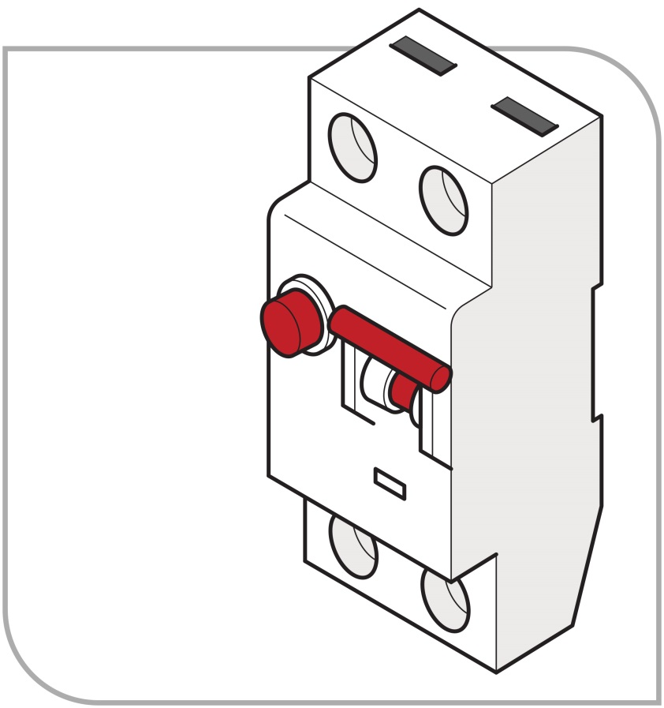
Figure 1: Switchboard RCD unit
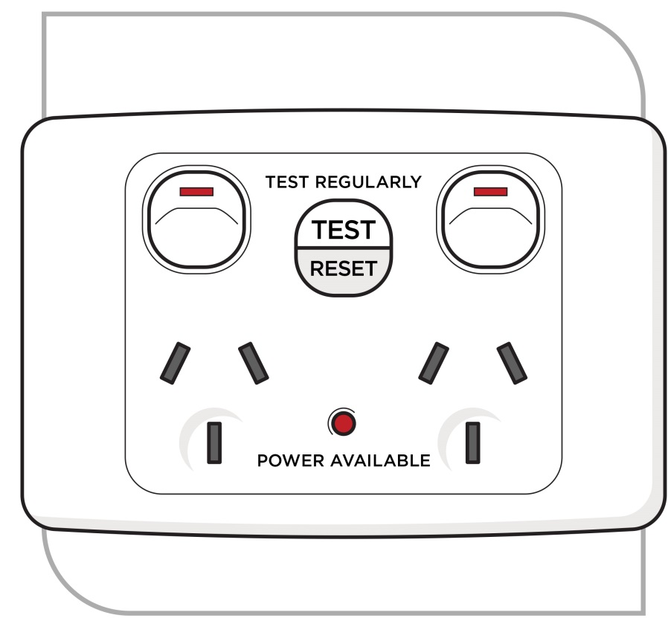
Figure 2: Fixed socket outlet RCD unit

Portable RCDs (Figures 3 and 4) are generally plugged into a socket outlet and, depending on design, may protect one or more items of electrical equipment.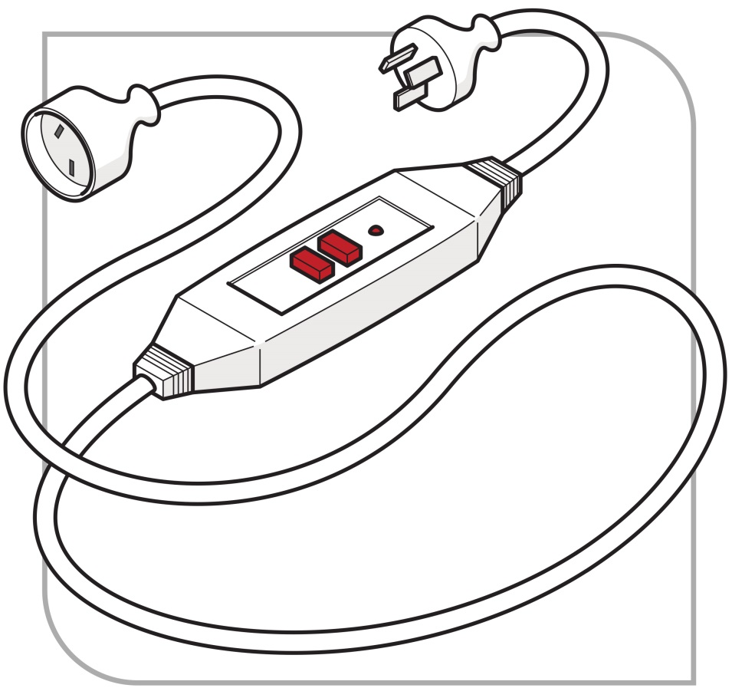
Figure 3: Portable RCD fitted directly to power cable
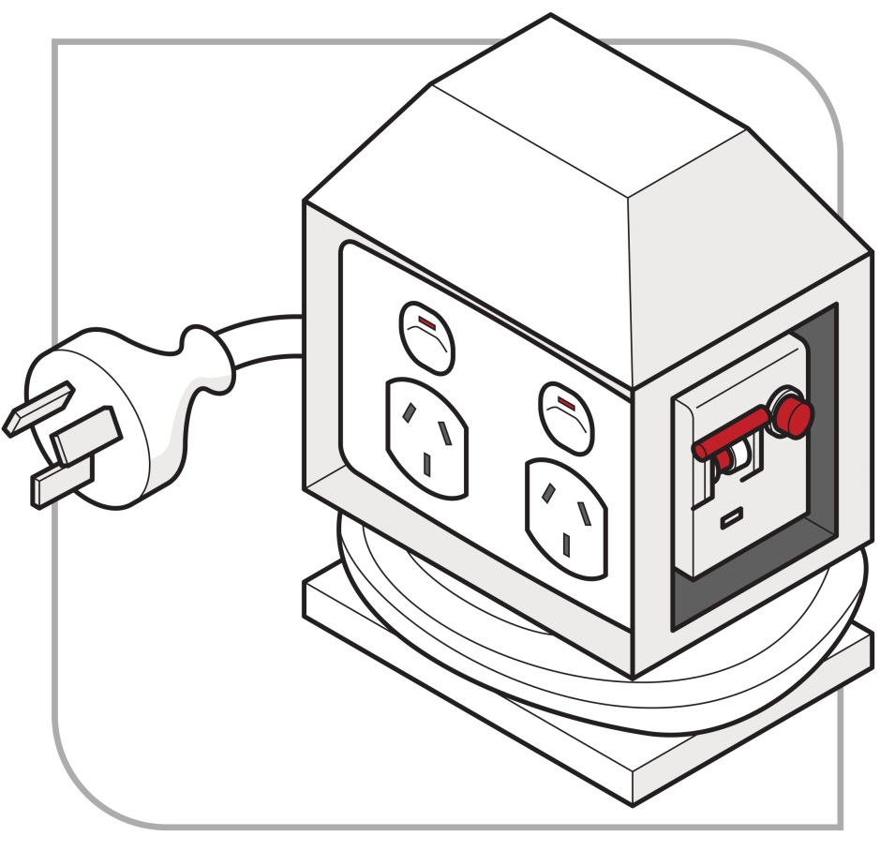
Figure 4: Portable RCD protected power board
To assist with proper selection, further information about the advantages and disadvantages of different kinds of non-portable and portable RCDs is included in Appendix 2 – Advantages and disadvantages of non-portable and portable RCDs.

Classes of RCDs
RCDs are classified in AS/NZS 3190: Approval and test specification – Residual current devices (current-operated earth-leakage devices).
The two relevant types of RCD are described in Table 1 below.
Table 1 Classes of RCDs—type, description and general guidance for use
Type | Description | General guidance – Use
Type I | Type I RCDs have a residual current rating not exceeding 10 milliamps and a tripping time within 30 milliseconds. | Type I RCDs are the most sensitive and are required for electrical equipment that is directly connected to people, for example patients in hospitals or dental practices.
Type II | Type II RCDs have a residual current rating greater than 10 milliamps but not exceeding 30 milliamps and a tripping time within 300 milliseconds. | Type II RCDs are most suitable for personal protection against injury including electric shock.

Construction and demolition sites
For construction and demolition sites you must comply with AS/NZS 3012:2010: Electrical installations – Construction and demolition sites.

Inspecting and testing RCDs
WHS General Regulations r. 165
WHS Mines Regulations r. 165
Testing of residual current devices
A person with management or control of a workplace must take all reasonable steps to ensure that RCDs used at the workplace are tested regularly by a competent person to ensure the devices are working effectively. This requirement covers RCDs used in all operating environments including non-portable (‘fixed’) RCDs.
A record of testing (other than daily testing) must be kept until the device is next tested or disposed of.
If an RCD is tested and found to be faulty it must be taken out of service and replaced as soon as possible.
Requirements for inspecting and testing electrical equipment used in certain higher risk workplaces which could, for example, include portable RCDs, are explained in section 3.2 of this Code.
AS/NZS 3012:2010/Amdt 1:2015: Electrical installations – Construction and demolition sites applies in relation to construction and demolition sites.
For guidance on approval and test specifications, see AS/NZS 3190 Approval and test specification – Residual current devices (current-operated earth-leakage devices).

Testing new portable RCDs
A new portable RCD unit should be tested by pressing the ‘trip test’ button to ensure the RCD is effective.

Work in roof spaces
WHS General Regulations r. 153
WHS Mines Regulations r. 153
Work in roof spaces

What is a roof space?
The roof space of a building means the space in the building that is:
- immediately under the roof, or
- if there is a ceiling under the roof, or a part of the roof, the space between the roof, or that part of the roof, and the ceiling.
For the purposes of this section, the roof space does not include a habitable room in the roof space. Regulation 153 of the WHS Regulations defines a building as a Class 1, Class 2 or Class 10a building as referred to in the Building Regulations 2012.

Work in roof spaces
A PCBU or person with management and control of a workplace must ensure that before work is done in the roof space of building at the workplace, the building’s electrical installation is de-energised by a competent person. In this case, a competent person must be able to identify the main switch, know how to switch it off, and know how to prevent unintentional re-activation (such as by locking or tagging out). The competent person must check that the electrical installation has been de-energised, for example by testing a light switch and attempting to turn on an electrical appliance.
A worker must not do work in the roof space of a building unless the building’s electrical installation is de-energised by a competent person.
If the roof space is divided into separate parts, each part relates to a separate dwelling, and a person cannot move between parts of the roof space (such a townhouse), the requirement to de-energise the roof space only applies to the roof space of the dwelling where work is being done.
The building’s electrical installation does not need to be de-energised if work is being done by a competent person to test, service or commission an appliance or other equipment, and:
- it is necessary to energise the appliance or equipment for the purpose of testing, servicing or commissioning it, and
- a risk assessment has been undertaken in accordance with Part 3.1 of the WHS Regulations, by a competent person who is familiar with the type of work to be carried out, and the competent person is satisfied that:
  - the risks identified by the risk assessment are, or can be, reduced to as low as reasonably practicable, and
  - the work can be carried out safely
- a safe work method statement (SWMS) for the work has been prepared in accordance with regulation 299 of the WHS Regulations.
Further information on conducting a risk assessment can be found in the Code of Practice: How to manage work health and safety risks.
Guidance on the preparation of a SWMS is available in the SafeWork Australia Safe work method statements for high risk construction work: Information sheet.
The requirement for the building’s electrical installation to be de-energised does not apply to:
- service apparatus that is part of the building’s electrical installation (Such as the overhead cable mains connection box, consumer mains cable, and kilowatt hour meter)
- a supply cable that is part of a building’s electrical installation if the cable is from a solar power system, wind turbine or battery, and it is not reasonably practicable to de-energise the cable
- any other part of a building’s electrical installation if it is not reasonably practicable to de-energise that part.

Working de-energised
Electrical work, whether energised or de-energised, must only be carried out by appropriately authorised electrical workers.
For more information about the applicable electrical licensing or registration laws, contact Building and Energy.

General principles—verification of de-energised electrical equipment
ELR r. 49
Requirements for electrical work
ELR r. 54A
Interpretation
WHS General Regulations r. 152
WHS Mines Regulations r. 152
Electrical work
A person conducting a business or undertaking (PCBU) or a person with management and control of the workplace must ensure that electrical work is only carried out on de-energised equipment unless subject to the prescribed exceptions under r. 55 of the ELR as discussed in section 6.1 of this Code.
Regulation 55 does not apply to electrical work carried out on or near the service apparatus of a major network operator if the work is carried out by or on behalf of the network operator

Testing whether equipment is energised
The most effective safety control measure is to de-energise the relevant part of the electrical installation and to ensure the work is not carried out near any part of the installation that remains energised.
Before any electrical work is undertaken, you must ensure the electrical installation or the relevant part of the electrical installation to be worked on:
- is tested by a competent person to ascertain whether or not it is energised, and
- if it is found to be energised, is de-energised by a competent person.
If an electrical installation is connected to a supply of electricity, each part of the installation is taken to be energised unless it is de-energised.
The procedure for de-energising and testing electrical installations is detailed in Building and Energy’s Code of Practice for Persons working on or near energised electrical equipment.
For more information about testing instruments see section 8.4 of this Code.

Work on or near electrical cables (including cutting cables)
Where work is to be carried out on or near an electrical cable, the cable should be de-energised and the isolation point secured by tagging and locking out.
Cables must be treated as energised and the procedures for working on energised electrical equipment must be followed, including testing by a competent person to determine whether or not they are energised (see section 4.1 above).
If the cable’s connections are exposed, the connections and attached parts should be proved to be de-energised and identified before work starts.
Cutting cables presents particular risks. Both ends of the cable should be checked for isolation prior to cutting. Schematic diagrams or ‘as built’ diagrams should be checked carefully to establish secondary or metering circuits in multi-cored cables prior to cutting.
Additional precautions should be taken to ensure insulated or covered cables are de-energised, whether the cables are low voltage, high voltage or control cables. For example, the action of cutting a multi-core control cable is likely to create a risk if secondary current from a current transformer is present. This risk may not be initially apparent; that is, the cable cutters may not be damaged when the cable is cut. A high voltage may develop across the open-circuited secondary winding causing an electric shock, arcing or a fault at a later stage. Depending on the situation, alternative precautions may include:
- using a cable spiking or stabbing device that is fit for purpose
- a combination of proving it is de-energised and physically tracing the cable.

Isolation, locking off and access
This section applies to workers who are not conducting electrical work, such as a worker isolating damaged or faulty machinery from the electricity supply. For electrical work on an electrical installation, additional requirements are mandated in the ELR. For further guidance, a detailed electrical isolation and de-energisation procedure can be found in Building and Energy’s publications Safe working guidelines for electrical workers and Code of Practice for Persons working on or near energised electrical installations.
Where electrical equipment or plant is damaged or faulty, it must be isolated from the electricity supply until it can be made safe.
To ensure electrical equipment remains de-energised while working, it should be effectively isolated from all relevant sources of electricity supply. This may be done by unplugging the equipment, opening switches, removing fuses or links, opening circuit breakers or removing circuit connections.
The PCBU or person with management or control of the workplace must consult with workers (for example in relation to the timing of the work) and notify any other affected persons as appropriate.
The standard steps for isolation are:
- Consultation and notification
- Isolation
- Securing the isolation
- Tagging
- Testing
- Re-testing as necessary

The effectiveness of isolation procedures relies on:
- isolation points being readily available, accessible and being suitable for the type of isolation (switching) being conducted
- the necessary hardware
- having isolation procedures documented and accessible to workers in the workplace
- the provision of instruction, information and training of workers
- appropriate supervision to ensure safe work procedures, including the isolation procedures, are followed.
Safe isolation procedures, including the use of locks and tags as discussed below, should be developed in consultation with relevant workers. If the workers are represented by a health and safety representative, the consultation must involve that representative.

Securing the isolation
ELR r. 54A
Interpretation
ELR r. 55
Electrical work on or near energised electrical installations
As a person conducting a business or undertaking (PCBU), you must ensure that each part of an electrical installation is treated as energised until it is isolated and de-energised.
You must also ensure that electrical equipment that has been de-energised to allow electrical work to be carried out on it is not inadvertently re-energised while the work is being carried out.
It is fundamental that the point of isolation should be under the control of the person who is carrying out the work on the isolated conductors.
Tagging systems should also be used at the point(s) of isolation, where possible, to provide general information.
The isolation should be secured by locking off and tagging the electrical equipment as outlined below.

Instruction, information, training and supervision
You must ensure instruction, information, training and supervision are provided, so far as is reasonably practicable, to ensure that electrical equipment that has been de-energised to allow electrical work to be carried out is not inadvertently re-energised. This includes appropriate instruction, information and training on isolation procedures.

Locking off
Isolation points should be fitted with control mechanisms that prevent the electrical equipment from being inadvertently re-energised. The control mechanism should require a deliberate action to engage or disengage the device. It should be able to withstand conditions that could lead to the isolation failing, for example vibration. This may include switches with a built-in lock, and lock-outs for switches, circuit breakers, fuses and safety lock-out jaws (sometimes called ‘hasps’).
All circuit breakers, switches and combined fuse switch units should be locked off to secure the isolation where possible. See Figures 5 and 6 below for examples of locking-off methods incorporating danger tags.
Alternative controls may include an additional component, for example a clip, screw, bolt or pin that can be inserted to prevent a switch from being operated. These types of controls should be used in conjunction with additional control measures, such as danger tags and permit systems.
If more than one person is working on the same de-energised electrical installation, individuals should ensure their own personal lock is applied to the isolation point, otherwise the principles of tagging apply (see below).
No-one should operate an isolator or knowingly use equipment where the isolator has a control mechanism attached.
In situations where isolation points are accessible by other persons at the workplace, you should ensure, so far as is reasonably practicable, that the isolation method or system is not able to be inadvertently or easily compromised.
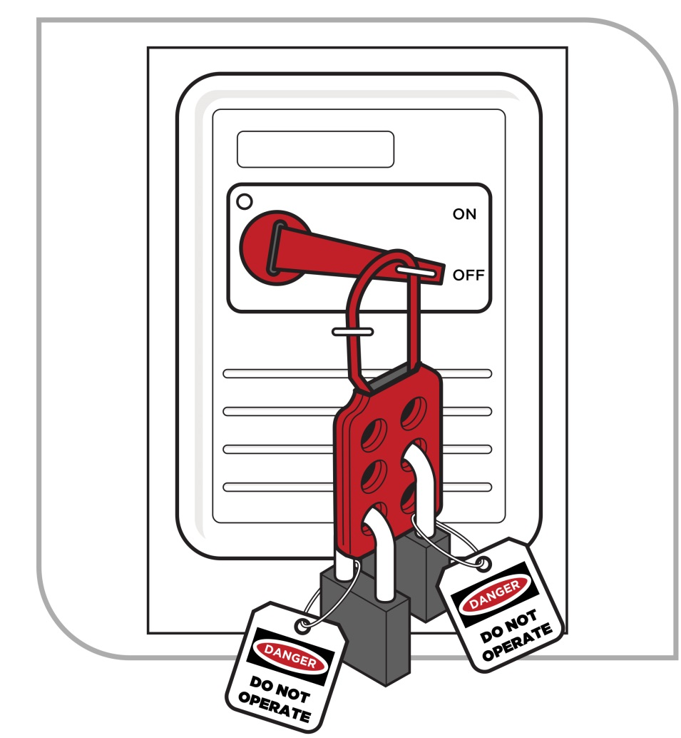
Figure 5 Locking off methods incorporating danger tags – danger tagged locking-off hasp.

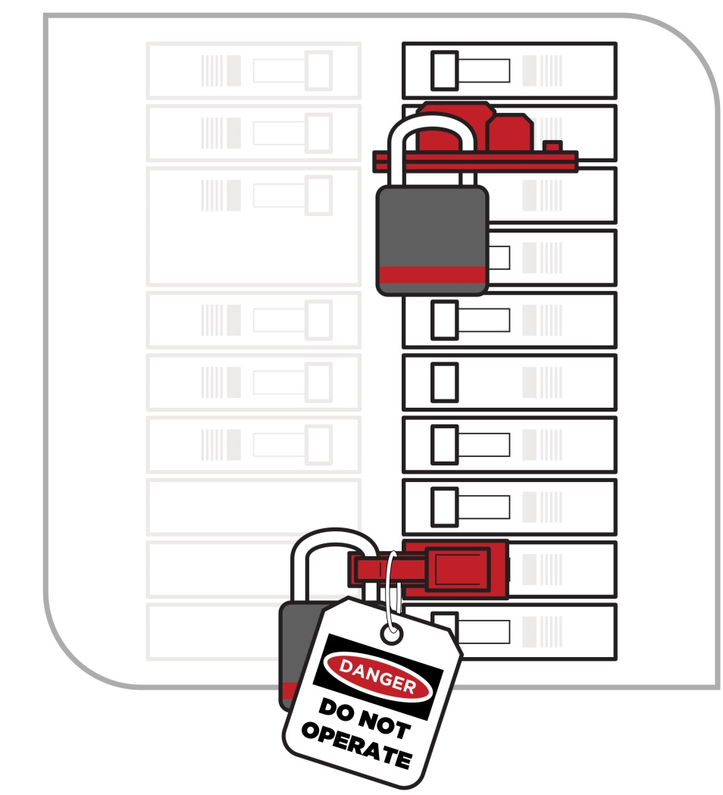
Figure 6 Locking off methods incorporating danger tags – danger tagged circuit breaker locking-off devices

Tagging systems

Danger tags
Isolation involves using suitable warning or safety signs as well as locks or other controls to secure the isolation.
Where possible, a tag should be attached to normal locks (as shown in Figure 5) at all points of isolation used to de-energise electrical equipment from its electricity supply.
A tag does not, by itself, perform the isolation function.
Danger tags are not required when using dedicated personal isolation locks.
Danger tags (see Figure 7) are used for the duration of the electrical work to warn persons at the workplace that:
- the electrical equipment is isolated or out of service
- the electricity supply must not be switched back on or reconnected
- reconnecting electricity may endanger the life of the electrical worker(s) working on the equipment.
The danger tag should:
- be durable and securely fixed to the isolator
- clearly state the warning, including any warning about specific hazards relating to the isolation (for example, multiple points of supply)
- be dated and signed by the worker or workers involved in carrying out the work or, where appropriate, by the supervisor in charge of the workers
- be attached in a prominent position on each isolation point (i.e. the point or one of many points used to isolate electrical parts) or device
- only be removed by the signatories to the tag. If unavailable and unable to return, measures must be put in place to manage risks associated with removing the lock or tag (for example thorough investigation to ensure all workers and others at the workplace are safe).
If the work is incomplete, for example at a change of shift, the last person removes their danger tag or lock and replaces it with a warning tag, for example out-of-service or caution tag.
When work is resumed, the person in charge of the work removes the warning (out-of-service or caution) tag and each person then applies their danger tag and/or lock.
When work is finally completed, each person removes their danger tag and/or lock.
Where a formal permit system is used, all reasonable steps should be taken to ensure that the designated sign-on and tagging procedures are followed.

Out-of-service tags
Out-of-service or caution tags (see Figure 8) are used to identify electrical equipment that is not safe to use or fit for purpose. The out-of-service or caution tag should:
- be durable and securely attached
- clearly state the nature of the defect or reason why the electrical equipment is unsafe
- be attached on a prominent position on each isolation point
- only be removed by a competent person after fixing or rectifying the defect and making the electrical equipment safe, or replacing with a danger tag in preparation to work on the equipment.
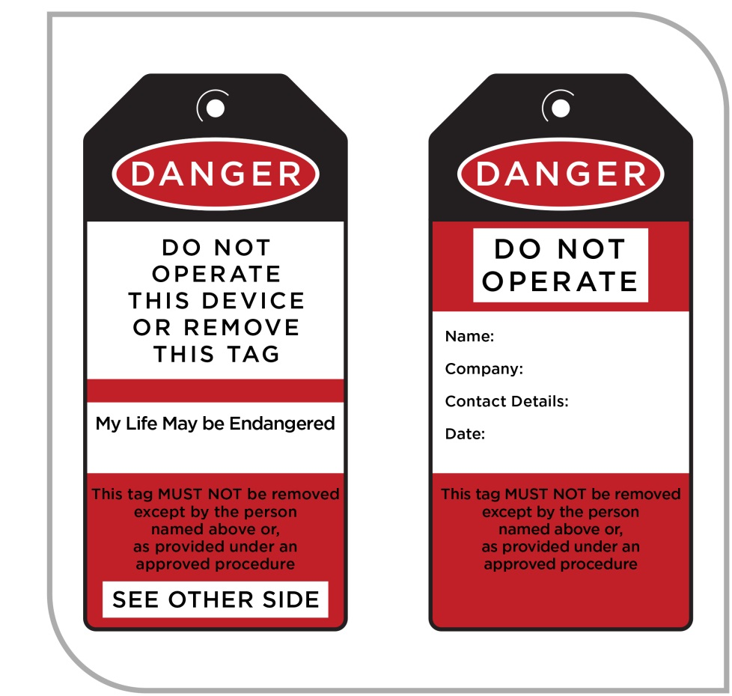
Figure 7: Example of a danger tag
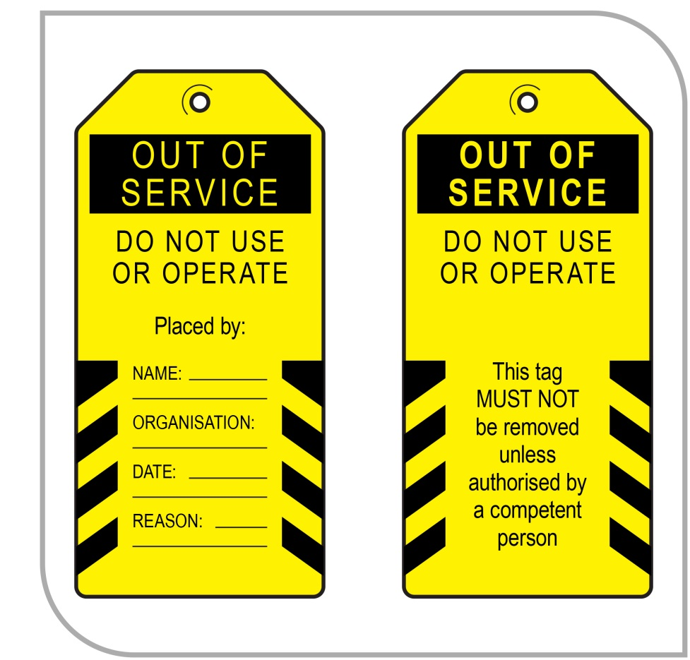
Figure 8: Example of an out-of-service tag

Testing
Electrical equipment must be tested by a competent person to confirm that it has been de-energised. For further information on tools used for testing refer to Section 8.4.

Restoring power
You must ensure, so far as is reasonably practicable, that restoring electricity supply following isolation does not pose risks to health and safety at the workplace. For example:
- check there are no exposed cable ends
- notify all workers working on the electrical equipment and other affected workers at the workplace that electricity is to be restored
- take precautions as appropriate to ensure that other electrical equipment is not inadvertently energised
- follow procedures for removing any locks or other control mechanisms, tags, notices and safety signs
- carry out a visual inspection to ensure that all tools, surplus material and waste have been removed from the workplace.

Leaving unfinished work
If work is left unfinished, you should ensure that the workplace is left in a safe state, so far as is reasonably practicable. For example:
- exposed cables are made safe
- tag and tape off the electrical equipment and the workplace area
- inform affected persons at the workplace the work is not complete and advise of potential hazards
- take any necessary precautions to ensure that electrical equipment cannot become inadvertently re-energised
- ensure that the status of switchboards and electrical equipment are clearly and correctly labelled
- hand over adequate information to workers taking up the unfinished work to allow them to continue the work safely.

Working on or near energised electrical installations
ELR r. 54A
Interpretation
ELR r. 54B
Application of regulation 55 in relation to certain network operators
ELR r. 55
Electrical work on or near energised electrical installations
WHS General Regulations r. 152
WHS Mines Regulation r. 152
Electrical work
WHS General Regulations r. 291
WHS Mines Regulations r. 291
Meaning of high risk construction work
WHS General Regulations r. 299
WHS Mines Regulations r. 299
Safe work method statement required for high risk construction work

Electrical work on or near energised electrical installations
Energised electrical work is electrical work carried out in circumstances where the part of electrical equipment being worked on is connected to electricity or ‘energised’.
Electrical work on or near energised installations is generally prohibited unless one or more of the exceptions under the ELR applies and the work is carried out in accordance with the ELR, WHS Regulations, and Building and Energy’s Code of Practice for Persons working on or near energised electrical installations.
Electrical work must never be carried out on or near an energised part of an electrical installation unless a risk assessment has been conducted by a competent person familiar with the type of work.
Electrical work must not be carried out on or near electrical equipment while energised for the reason of it being merely more convenient for the electrical equipment to stay energised while the work is being carried out.
Electrical work must not be carried out on or near unless the safety risk to those persons directly affected by a supply interruption is higher than the risk to the licensed or registered electrical workers proposed to carry out the energised electrical work. Only in extremely rare circumstances would it be possible to justify that it is not practicable to have a short break in supply. Most electrical installations suffer no harm through unplanned interruptions of this kind to the network supply. In some cases a short break may allow for the insertion (and removal) of insulated barriers.
A PCBU requiring electrical work to be carried out may provide operational reasons appearing to justify energised electrical work. Requiring electrical work to be carried out while the equipment is energised when it could be avoided places an onerous responsibility on the business or undertaking to manage the risks. If an incident occurs as a result of carrying out energised electrical work, the business or undertaking is at risk of being found not to have provided a safe workplace.
A SWMS must be prepared in accordance with r. 299 of the WHS Regulations, regardless of whether the work is to be carried out on a construction site. The work must be carried out in accordance with the SWMS. Work must cease if the SWMS is not complied with.
These requirements in relation to energised electrical work do not apply to work carried out on or near the service apparatus of a major network operator if the work is carried out by a network operator. These operators are covered by separate electrical safety requirements.
Suitable personal protective equipment must be used properly by the person carrying out the work.
Planning and preparation must be carried out in accordance with the ELR, WHS Regulations, and Building and Energy’s Code of Practice for Persons working on or near energised electrical installations.

Risk assessments
See section 2.2 of this Code for information on assessing the risks.
In addition to the considerations listed in section 2.2, the assessment should be designed to check compliance with the legislative requirements described above from regulation 55 of the ELR.
For energised electrical work, any significant findings should be recorded, reviewed from time to time and revised if necessary. See section 2.4 of this Code for a description of triggers for review.
The risk assessment should determine whether a safety observer is required. Building and Energy’s Code of Practice for Persons working on or near energised electrical installations outlines the role and requirements for safety observers.

Consultation between duty holders
When electrical work is being carried out at a workplace all PCBUs at the workplace—not just those carrying out the electrical work—have a duty to manage electrical risks.
Electrical work will often be carried out at a place that is not under the management or control of the PCBU carrying out the electrical work. For example, the place where work is carried out may be under the management or control of:
- if the place is a permanent workplace—the PCBU from that workplace
- if the place is a public place—the relevant local or State authority.
These persons will also have duties in relation to the health and safety of the electrical worker(s) and other persons at the place where the electrical work is being carried out.
If duty holders have a duty in relation to the same matter under the WHS Act, all duty holders must, so far as is reasonably practicable, consult, cooperate and coordinate activities with each other in relation to this matter.
In addition to the general duty to consult, the PCBU carrying out the electrical work must ensure the electrical work is only authorised (among other things) after consulting with the person with management or control of the workplace.
Consultation should ensure that all relevant persons are aware of any scheduled electrical work to be carried out and also of any relevant risks to health and safety arising from that work.
Arrangements should also be put in place to ensure, so far as is reasonably practicable, that all persons at the workplace receive suitable and adequate information and instruction, for example about the need to comply with warning or safety signs and to stay out of any danger zones.
You must consult to determine whether the electrical work on or near energised electrical equipment is carried out:
- by a person authorised under the ELR
- in accordance with a safe work method statement prepared for the work (see the following section), and
- subject to the exception outlined in Building and Energy’s Code of Practice for Persons working on or near energised electrical installations – with a safety observer present who is competent:
  - to implement control measures in an emergency
  - to rescue and resuscitate the worker who is carrying out the work if necessary, and
  - has been assessed in the previous 12 months as competent to rescue and resuscitate a person.
Additionally, you:
- must ensure there are first aid facilities provided at the workplace and each worker has access to the equipment
- must inform workers if the workplace contains a hazardous atmosphere that may introduce additional electrical hazards
- should ensure emergency contact numbers are available at the workplace
- should ensure firefighting equipment that is suitable for electrical fires is accessible
- must ensure the person with management or control of the workplace is consulted before the electrical work is authorised
- should ensure unauthorised persons are prevented from entering the work area, for example through the use of barriers and signage.
Many of these requirements and recommendations require consultation, cooperation and coordination between multiple duty holders at the workplace.

Residential premises
Occupiers of residential premises must take reasonable care that their acts or omissions do not adversely affect the health or safety of other persons while work is being performed at the premises. This includes electrical workers at their premises.

Safe work method statements
ELR r. 55
Electrical work on or near energised electrical installations
WHS General Regulations r. 299
WHS Mines Regulations r. 299
Safe work method statement required for high risk construction work
WHS General Regulations r. 300
WHS Mines Regulations r. 300
Compliance with safe work method statement
WHS General Regulations r. 302
WHS Mines Regulations r. 302
Review of safe work method statement
WHS General Regulations r. 303
WHS Mines Regulations r. 303
Safe work method statement must be kept
You must ensure that electrical work on energised electrical equipment is carried out in accordance with a safe work method statement (SWMS).
SWMS document a process for identifying and controlling health and safety hazards and risks. They may also incorporate a risk assessment.
SWMS are required in relation to prescribed ‘high risk construction work’ which includes construction work carried out on or near energised electrical installations or services.
SWMS must be developed in consultation with relevant workers. If the workers are represented by a health and safety representative, the consultation must involve that representative.
SWMS prepared for energised electrical work should describe consultation arrangements with the person with management or control of the workplace, including any authorisation procedures and position descriptions.
SWMS must:
- identify the electrical work
- specify the hazards associated with that electrical work and risks to health and safety associated with those hazards
- describe the measures to be implemented to control the risks
- describe how the control measures are to be implemented, monitored and reviewed, and
- may include the risk assessment prepared for the relevant work.
SWMS must be written in a way that is readily understandable by the workers who are to use them.
A copy must be readily accessible to any worker who is to carry out the electrical work covered by the statement.
You must ensure that SWMS are reviewed and, as necessary, revised if relevant control measures are revised under the WHS Regulations. They must, for example, be revised if a decision is made to change relevant safe work procedures at the workplace.
Appendix 4—Preventative actions checklist may help you to identify hazards associated with electrical work and assist you to develop safe work methods.
If the electrical work falls within the description of high risk construction work then the construction regulations in the WHS Regulations will apply. For more information about safe work method statements for high risk construction work see the Code of Practice: Construction work.

Record keeping requirements
As a PCBU, if a ‘notifiable incident’ under Part 3 of the WHS Act occurs in connection with the work to which the SWMS relates you must keep the SWMS for at least two years after the incident occurs.
You must ensure that, for the period for which the SWMS must be kept under the WHS Regulations, a copy is readily accessible to any worker you engage to carry out electrical work to which the SWMS relates, and a copy is available for inspection.

Hazards indirectly caused by electricity—conductive materials
Persons can be exposed to electrical risks, including risks of electric shock, arcing and explosion, without directly contacting exposed energised parts of electrical equipment. Other conductive materials can provide current paths for the electric shock, fault current or both.
All materials should be regarded as conductive unless proved otherwise. Gases and liquids should be regarded as conductive. Particular care should be taken when exposed energised parts are near earthed situations.
The electric shock path to earth can be via conductive materials such as concrete, timber with a high moisture content, or water. For example, ladders that are damp or dirty may become conductive and create a potential hazard.
When working on or near exposed energised parts, use tools and equipment that are non-conductive or insulated. This applies, for example, to:
- torches
- telescopic devices
- rulers and tape measures
- insulated hand tools, for example, screwdrivers, pliers, cable cutters, spanners and crimpers, and
- electrical or hydraulic powered tools.
Metallic personal items including watches and watchbands should not be worn by workers carrying out work near exposed energised parts. Metal objects worn on or close to the body increase the risk of electric shock. Electrical burns can be more serious because these objects retain heat and provide contact points for current to flow.
Other examples of metallic personal items include jewellery, body piercings and metal spectacle frames.

Tools and equipment
All workers should be competent in the safe use of their tools and equipment, including PPE. For more information about maintaining and inspecting tools and equipment, including testing and fault-finding instruments, see section 8 of this Code.

Safety barriers and signs
Barriers and signs may be designed, erected or installed as outlined in Building and Energy’s Code of Practice for Persons working on or near energised electrical installations.

Emergency planning
ELR r. 63
Electrical accidents to be reported
WHS Act s. 38
Duty to notify of notifiable incidents
WHS General Regulations r. 43
WHS Mines Regulations r. 43
Duty to prepare, maintain and implement emergency plan
You must ensure that an emergency plan for the workplace is prepared, maintained so that it remains effective, and implemented in the event of an emergency.
For the purpose of preparing and maintaining the plan, you must consider all relevant matters, including:
- the nature of the work being carried out at the workplace
- the nature of the hazards at the workplace
- the size and location of the workplace
- the number and composition of the workers, and
- other persons at the workplace.
Quick action after an electrical incident that has caused injury can save a life or significantly reduce the severity of the injury. Any person who is involved in an electrical incident involving an electric shock should receive medical attention.
Even if an electrical incident does not appear to have caused injury at the time, there may be delayed effects.
A well prepared emergency response will assist in managing the severity of the injury where an incident has occurred, while also taking into account the health and safety of those required to respond to the incident. For example, in an exposed energised high voltage situation, the plan may include isolating the electricity supply and proving it is de-energised before carrying out a rescue.
Special consideration must also be given in relation to other higher risk workplaces including confined spaces, working at heights, use of elevating work platforms, workplaces with hazardous atmospheres which present a risk to health or safety from fire or explosion, and trenches, shafts and tunnels.
You must ensure that the regulator is notified immediately after you become aware of any incident arising out of the business or undertaking that has exposed a worker or any other person to a serious risk from an immediate or imminent exposure to electric shock. This may also be separately notifiable to an electrical safety regulator. Appendix 6 contains further information and contact details.

Hierarchy of control measures
You must work through the hierarchy of controls to choose the control measures that most effectively eliminate or minimise the risk of working near energised electrical parts, so far as is reasonably practicable. See section 2.3 for information on the hierarchy of control measures.
Some examples of control measures for working near energised electrical parts are below.
Elimination
- To eliminate the hazard, before starting work electrically isolate the nearby electrical equipment or installation. When disconnecting the equipment or installation from supply, apply a method to ensure it is not reconnected while the work is carried out (for example place the plug in a lockable enclosure). If equipment is connected to supply by fixed wiring, use other suitable means of isolation as discussed in Chapter 6 of this Code. Clearly document the isolation process so that everyone involved knows exactly what to do.
- Redesign equipment or work processes so there are no energised parts near the work area.
Substitution, isolation and engineering controls
- Replace a hazardous process or material with one that is less hazardous – for example replace instead of repairing a faulty part. This could mean shorter downtime and not having to work energised, thereby lessening or eliminating the risk of exposure.
- Erect a physical barrier made of a non-conductive material such as wood or plastic or, alternatively, correctly earthed metal. Before any barriers are erected, a risk assessment must be carried out by a competent person to ensure the appropriate design and correct materials are used. The barrier must be erected safely. This may require isolating the electricity supply while the barrier is installed. The barrier must be strong enough to withstand any impact from falling objects or loose materials.
- Install residual current devices to prevent electric shock.
Administrative controls
- Provide suitable and adequate training.
- Establish exclusion zones.
- Use permits and warning signs.
Personal protective equipment (PPE)
- PPE (for example protective eyewear, insulated gloves, hard hats, aprons and breathing protection) should be rated for the work to be done. If working on or near energised equipment, the PPE must be able to protect the user from the maximum expected energy available at the work site.

Implementing control measures
In implementing control measures, you must develop a SWMS that:
- specifies the determined control measures
- sets out the steps that need to be taken to implement the control measures
- identifies and allocates the resources necessary to implement the control measures (i.e. time and expenses)
- allocates responsibilities and accountabilities (for example who does what and when), and
- sets a date for reviewing the control measures.

Reviewing control measures
See section 2.4 of this Code.

Tools and equipment

Maintenance and inspection
WHS General Regulations r. 152
WHS Mines Regulations r. 152
Electrical work
Tools, instruments and equipment that are poorly maintained, inappropriately used or not fit for purpose can cause injuries. Examples of these include:
- inadequately insulated tools and test instruments
- incorrectly rated instruments.
Unrestrained tools may fall into energised switchboards and compromise the integrity and safety of the equipment. The use of lanyards around wrists, tool holders, and restraints such as tool pouches and baskets may be used to address these risks.
The tools, instruments and equipment used by electrical workers often have special design characteristics, for example many are insulated. All insulated tools and equipment should be suitable for the work and be maintained in good working order, including regular maintenance, inspection and testing. Inadequate maintenance may lead to serious electrical risks, for example an insulating medium might conceal a mechanical defect that could cause an open circuit in a testing device.
Where any doubt exists about the adequacy of the insulation of tools and equipment they should not be used.
Maintenance and inspection should be carried out according to the manufacturer’s instructions.

Ladders, scaffolds and similar equipment
Consider eliminating the use of metallic, wire reinforced or otherwise conductive ladders. These types of ladders should be avoided for any kind of electrical work and should not be used in close proximity to equipment where an electrical hazard may result from their use.
Metallic or wire reinforced ladders and scaffolds are conductive and may create an electric shock path, for example:
- a ladder slipping while work is being carried out on it, causing the worker on the ladder to touch exposed energised parts, for example grabbing a mains box
- a gust of wind blowing an extension ladder into nearby overhead powerlines
- in switchrooms and switchyards – conductive devices such as aluminium ladders and scaffolds creating electric shock paths and current paths to earth, for example a metal wire reinforced ladder causing a fault to ground if the ladder touches an energised busbar
- in cases where lines are carrying large currents, conductive scaffolds may become subject to induction.
Also consider the electrical risks posed when using ladders, scaffolds and similar equipment, including that:
- workers are more likely to touch open wiring such as overhead lines, and
- portable scaffolds may damage insulation when moved if the scaffold strikes conductors or leads.

Other effective control measures may include:
- identify if there are exposed energised parts nearby and consider control measures such as de-energising, fitting covers, using a safety observer, or a combination of these
- employ safe work practices, including:
  - in switchyards and switchrooms if long devices need moving, use two or more people to carry the device in a position below shoulder height
  - in windy conditions use two people to handle extension ladders
  - use head ropes or footropes or both to restrain ladders
  - if practicable use a platform-style step ladder.
- if conductive scaffolding is used within high voltage enclosures or in situations where there is induction, bond the structure to the earthing system. Depending on the construction of the scaffold, a number of sections may need to be bonded to ensure an equipotential state.

Insulating barriers and insulating mats
Insulating covers and mats used for electrical safety purposes should comply with AS/NZS 6111: Live working – Electrical insulating mats.
Insulated barriers should be of suitable material to effectively separate electrical workers from adjacent energised equipment.
Insulated covers and mats should be visually inspected for possible defects before and after each use.

Test instruments
As a person conducting a business or undertaking (PCBU), you must ensure that the person carrying out energised electrical work has tools, testing equipment and PPE that are suitable for work, that have been properly tested and that are maintained in good working order.

Proximity voltage testers
To confirm a positive indication and to establish the circuit voltage, the use of an alternative test instrument that incorporates a visual display should be used before starting electrical work on the equipment.
Testers for detecting an electric field surrounding an energised conductor may not be suitable for testing cables that are surrounded by a metallic screen, enclosed in a metallic pipe or duct, carrying direct current, and some other circumstances.
Proximity voltage testers are not reliable in proving that equipment is de-energised and should only be treated as an indicator. To confirm that the instrument is working correctly, a proximity voltage tester should be tested for correct operation immediately before use and again immediately after use, particularly if the test result indicates zero voltage.
For further information on test instruments, please refer to the ELR and Building and Energy’s Code of Practice for persons working on or near energised electrical installations.

Personal protective equipment
ELR r. 55
Electrical work on or near energised electrical installations
WHS General Regulations r. 44
WHS Mines Regulations r. 44
Provision to workers and use of personal protective equipment
You must ensure that personal protective equipment (PPE) for electrical work, including testing and fault finding, is selected to minimise risks to health and safety; maintained, repaired or replaced so that it continues to do so; and used or worn by the worker, so far as is reasonably practicable.
A PCBU who directs the carrying out of work must provide the workers with information, training and instruction on the proper use and wearing of the PPE.
Depending on the type of work and the risks involved, the following PPE should be considered.
- Face protection
- Eye protection
- Gloves
- Clothing
- Footwear
- Safety belt/harness
Further information refer to regulation 55 of the ELR and Building and Energy’s Code of Practice for Persons working on or near energised electrical installations.

First Aid
WHS General Regulations r. 42
WHS Mines Regulations r. 42
Duty to provide first aid
All PCBUs must ensure the provision of first aid for the workplace, and that each worker at the workplace has access to the facilities and equipment for the administration of first aid.
You must ensure that an adequate number of workers are trained to administer first aid at the workplace or workers have access to an adequate number of other persons who have been trained to administer first aid.
All electrical workers and their assistants should have current low voltage rescue and resuscitation skills.
Certain energised work may require a safety observer if deemed necessary by the risk assessment. See Building and Energy’s Code of Practice for Persons working on or near energised electrical installations for further information.
For further guidance on how to provide first aid refer to the Code of Practice: First aid in the workplace.

High voltage electrical work
Requirements for electrical work on high voltage equipment after switching, isolation, short circuiting and earthing are specialised requirements. Only competent electrical workers who have received appropriate training in high voltage electrical work are permitted to work on high voltage electrical equipment.
For more information you should seek further advice about working on or near high voltage electrical installations from a specialist electrical contractor or your network operator.

Additional risks associated with high voltage
The electrical risks and consequences of an electrical incident involving high voltage may be significantly higher than with low voltage. Under fault conditions, the higher voltages (potentials) and fault current levels release massive quantities of energy.

Planning for high voltage installation work
A person conducting a business or undertaking (PCBU) that has a high voltage electrical installation should prepare an installation safety management plan for their workplace. The plan should address the risks associated with the operation and maintenance of the high voltage installation. This may include:
- a single line diagram for the installation, showing all switches and circuit breakers and their identifying labels or numbers
- site-specific operating rules covering all aspects of operating the high voltage installation, including procedures for arranging isolation of the installation from the local electricity network
- procedures for identifying hazardous areas including any confined spaces associated with the installation
- competency requirements for persons who may be permitted to operate or work on the high voltage installation, including appropriate requirements for re-training, re-testing and re-accreditation
- induction procedures for new contractors
- regular inspection and maintenance programs to ensure the installation remains serviceable and safe
- procedures for ensuring there is no extension or alteration of the installation without permission from the local electricity supply authority
- procedures for the safe handling of insulating oils and other substances that may be required for maintenance or repair
- procedures including warning signs for ensuring that no parts of the high voltage installation (for example underground cables and high voltage overhead powerlines) are damaged by heavy vehicles or other mobile plant, for example mobile cranes.

For further information, please refer to Building and Energy’s Guidelines for the Safe management of high voltage electrical installations.

Electricity in mines
The WHS Mines Regulations contain additional requirements for the management of electrical risks on mine sites.

Managing electrical risks in mines
WHS Mines Regulations r. 641A
Managing risks due to electricity
WHS Mines Regulations r. 641G
Electrical work to be carried out by licensed persons
WHS Mines Regulations r. 641H
Working in close proximity to uninsulated high voltage conductors or components
The mine operator of a mine must manage risks to health and safety associated with electricity at the mine, including risks associated with the generation, transmission, use or storage of electricity at the mine, including:
- the design, selection, installation, commissioning, operation, testing and maintenance of electrical equipment and electrical installations and use of electricity at the mine, including:
  - safe and secure location
  - rating
  - provision of appropriate switchgear
  - prospective electrical fault level
  - arc fault control
  - minimising potential impacts from voltage rise due to lightning, static electricity, voltage surges and other transient voltages to within acceptable limits
  - reliable circuit interruption, under fault conditions, at all points in the mine’s electrical distribution system
  - electrical protective devices
  - hazardous atmosphere
- signage and warnings
- written procedures for critical operations and dealing with emergencies
- effective supervision and communications
- competencies of persons working with or near electrical equipment and installations.

Electrical work to be carried out by licensed persons
The mine operator must ensure that a person is not permitted to carry out electrical work at the mine unless they have a licence or permit issued under the ELR.

Working in close proximity to uninsulated high voltage conductors or components
The mine operator must ensure that:
- a person does not operate plant in close proximity to uninsulated high voltage conductors or components unless they are authorised to do so by a high voltage vicinity permit
- the high voltage operator issuing the high voltage vicinity permit details the measures for the safe operation of the plant in close proximity to uninsulated high voltage conductors or components on the permit, and those measures are carried out.

Records to be kept
WHS Mines Regulations r. 641B
Records to be kept relating to electricity at mine
The mine operator must keep the following records at the mine:
- up to date plans showing the location and details of:
  - all low voltage and high voltage cabling and plant installed at the mine
  - all low voltage and high voltage cables installed in the ground at the mine
  - main switches provided at the mine
- copies of any compliance and test certificates relating to plant used or installed in hazardous areas at the mine.

Electrical log books
WHS Mines Regulations r. 641C
Electrical log books
The mine operator of a mine must ensure that an electrical log book for the mine is kept at the mine that is in the approved form and contains up to date details of:
- inspections and testing of electrical equipment
- the most recent test of in-use residual current devices
- all electrical installing work carried out at the mine
- incidents where the electrical supervisor stops any dangerous electrical plant or installation
- incidents where the electrical supervisor reports any situation which may affect the safe use of electricity to the site senior executive or exploration manager
- investigations or reports the electrical supervisor submits to the site senior executive or exploration manager of any:
  - electric shock or burn received by a person
  - fire suspected to be caused by electricity
  - dangerous occurrence involving electricity which could have caused injury to a person.

Earthing systems
WHS Mines Regulations r. 641D
Earthing systems
The mine operator of a mine must ensure:
- any earthing system installed in a quarry operation or an underground mine is connected to the earthing system established at the surface of the mine by means of a continuous earthing conductor
- no earthing electrode is installed in a quarry operation or an underground mine
- the neutral point of an alternating current electrical system is effectively earthed to the main earthing system
- an earthing system that incorporates an impedance complies with the requirements for protection against indirect contact in AS/NZS 3007:2013: Electrical equipment in mines and quarries
- any single phase alternating current apparatus that is installed in a quarry operation or an underground mine is supplied from a double wound transformer having one pole of the secondary winding connected to earth.

Trailing cables and reeling cables
WHS Mines Regulations r. 641E
Trailing cables and reeling cables
Trailing and reeling cables are electrical power cables for mobile apparatus, such as large excavators, draglines, stackers and reclaimers. The cable allows the mobile apparatus to move without disconnecting its electric power supply.
A reeling cable is specifically designed to be frequently reeled on and off a cable drum or reeler (e.g. an iron ore rail-mounted reclaimer), whereas a trailing cable is specifically designed to be moved with the mobile apparatus (e.g. a coal mine dragline, mineral sands mobile processing plant).
The mine operator of a mine must ensure that any trailing cable and reeling cable at the mine:
- conforms to
  - AS/NZS 1802:2018: Electric cables - Reeling and trailing - For underground coal mining if the mine is an underground coal mine
  - AS/NZS 1747:2003: Reeling, trailing and feeder cables used for mining - Repair, testing and fitting of accessories if the mine is not an underground coal mine
- incorporates a pilot core arranged to cut off the supply of electricity in the event of a break in the earthing circuit
- is installed, located and used in a way that minimises the risk of damage to the cable and to any connecting or coupling device
- is repaired and tested in accordance with AS/NZS 1747:2003.

Earthing continuity protection and monitoring
WHS Mines Regulations r. 641F
Earth continuity protection and monitoring
The mine operator must ensure that a system is provided to monitor the earth continuity that automatically disconnects the electricity supply to a cable in the event of a break in the earth conductor for:
- any mobile plant operating from either trailing cables or reeling cables
- any other plant for which the supply cable may be exposed to damage due to tension
- any equipment connected by restrained plugs and receptacles complying with AS/NZS 1299:2009: Electrical equipment for mines and quarries - Explosion-protected three-phase restrained plugs and receptacles for working voltages up to and including 3.3 kV.

Mine safety management system
WHS Mines Regulations pt. 2 div. 1 sub-div. 2
Mine safety management system
WHS Mines Regulations pt. 2 div. 1 sub-div. 2A
Contractor management
WHS Mines Regulations pt. 2 div. 2
Principal mining hazard management plans
WHS Mines Regulations pt. 2 div. 5 sub-div. 1
Emergency plan – all mines

The mine operator should consider electrical hazards and electrical work when establishing and implementing the MSMS, including:
- whether an electrical hazard at the mine could constitute a principal mining hazard
- contractor management of electrical contractors
- the provision of information, training, and instructions regarding electrical hazards, including control measures
- procedures for reporting electrical incidents.
Further information on MSMS can be found in the Code of Practice: Mine safety management system, the Information Sheet: Content of mine safety management system and the Information Sheet: Overview of the mine safety management system code of practice.

Emergency plan
When developing an emergency plan for a mine site, the response to an electrical incident should be considered along with the procedures and control points for utilities, including electricity. These procedures should include provisions for isolation and alternate supply as required during an emergency, as well as the increased danger electricity could have when interacting with another hazard, such as a fire.

Statutory positions

WHS Mines Regulations sch. 26
Statutory positions
The WHS Mines Regulations detail the requirements for the appointment of persons to statutory positions, which have specific workplace health and safety responsibilities.
Statutory positions are classified in several categories, which impose different obligations on the appointed person and require different levels of knowledge, experience and formal qualifications.
The WHS Mines Regulations prescribe statutory positions that have to be in place where working around electricity, including:
- electrical supervisor
- high voltage operator.
Persons appointed to these positions must meet the requirements outlined in the WHS Mines Regulations.

Electrical supervisor
An electrical supervisor must be appointed for a mine where electrical work is carried out by an electrician and is generally responsible for:
- ensuring the efficient and adequate supervision of the installation, maintenance, testing and safe operation of electrical plant and installations
- stopping the use of any electrical plant or installation considered dangerous
- recording up to date information in the electrical log book (see section 10.3)
- investigating and reporting:
  - any electric shock or burn
  - any fire suspected to be caused by electricity
  - any dangerous occurrence involving electricity which could have caused injury to a person.

High voltage operator
A high voltage operator must be appointed for a mine that has high voltage installations or where high voltage electricity is used and are generally responsible for:
- issuing high voltage vicinity permits authorising people to work or operate any plant in close proximity to uninsulated high voltage conductors or components
- ensuring measures for the safe operation of the plant in close proximity to uninsulated high voltage conductors or components are:
  - detailed on the high voltage vicinity permits
  - are carried out
- isolating high voltage equipment at the mine so that the equipment can be accessed, maintained or repaired, and re-energising the equipment.

Appendix 1—Glossary
Term | Description
Competent person | - For electrical work (other than testing referred to in WHS Regulations 150 and 165) means a person authorised by licence or permit under the ELR (for example, licensed electrician, restricted licence holder, supervised electrical apprentice).  - For inspection and testing of electrical equipment, means a person who has satisfactorily completed competency-assessed training course on testing and tagging using the pass-fail type of electrical instrument known as a portable appliance tester.  - For any other case mentioned in this Code of Practice, a person who has acquired through training, qualification or experience, the knowledge and skills to carry out the task.
Duty holder | Any person who owes a work health and safety duty under the WHS Act including a person conducting a business or undertaking, a designer, manufacturer, importer, supplier, installer of products or plant used at work (upstream duty holder), officer or a worker.
De-energised | In relation to a part of an electrical installation means separated from each supply of electricity to the part in such a way that the part cannot be inadvertently energised.
ELR | Electricity (Licensing) Regulations 1991
Electrical appliance | A device in which electrical energy is consumed or substantially changed in character including by conversion into heat, sound, motion, light.
Electrical contractor | Means a person who carries on business as an electrician but does not include an electrician when acting in the capacity of an employee of an electrical contractor.
Electrical equipment | Includes any component or part of an electrical installation
Electrical installation | Includes all wiring, wiring enclosures, switch gear, control and protective gear, appliances, and other components permanently connected to or associated with the wiring, on premises to which electricity is or is intended to be supplied through distribution works, and where electricity is supplied from a private generating plant includes that plant.
Electrical installing work | Electrical work that consists of assembling and fixing in place, altering or adding to any electrical installation or maintaining, removing or connecting to fixed wiring, any electrical equipment.
Electrical supervisor | A person appointed to the statutory position on a mine site under Schedule 26 clause 5.  An electrical supervisor must have:  - either an electrician’s licence or be an electrical engineer eligible for membership of Engineers Australia  - completed an approved WHS risk management unit for electrical supervisors, and  - two years’ experience carrying out electrical work in the mining industry or another heavy industry.
Electrical work | Work:  - on machines or instruments, an electrical installation, or electrical appliances or equipment to which electricity is supplied, or intended to be supplied, at a nominal pressure exceeding 50 V a.c. or 120 V d.c.  - comprising an assessment of an electrical installation to ensure that the installation and any work done on the installation complies with the requirements of the ELR.
Electrical worker | An individual who carries out electrical work.
Electrical worker’s licence | A licence issued under Part 3 of the ELR.
Electrician | An electrical worker who is authorised by a licence to carry out electrical installing work and electrical fitting work.
Energised | In relation to a part of an electrical installation, means connected to a supply of electricity to the part, whether or not electricity is flowing through any of that part.
Hazard | A situation or thing that has the potential to harm a person. Hazards at work may include: noisy machinery, a moving forklift, chemicals, electricity, working at heights, a repetitive job, bullying and violence at the workplace.
Health and safety representative | A worker who has been elected by their work group under the WHS Act to represent them on health and safety matters.
High voltage operator | A person appointed to the statutory position on a mine site under Schedule 26 clause 6.  the person successfully completes a high voltage operator training course that is approved by the regulator under regulation 675ZZK(1)(d)  A high voltage operator must:  - have completed an approved high voltage operator course, and  - know how to operate switchgear to isolate and re-energise high voltage equipment.
Isolated | Disconnected from all possible sources of electricity supply and thereby rendered incapable of being made energised without premeditated and deliberate action.
Licensed electrical worker | The holder of an electrical worker’s licence or permit issued under Part 3 of the ELR.
May | ‘May’ indicates an optional course of action.
Maintenance work | Repairing defective electrical equipment or replacing electrical equipment with electrical equipment having an equal or substantially similar engineering specification.
Must | ‘Must’ indicates a legal requirement exists that must be complied with.
Near | For the purposes of this Code, working near an energised electrical installation is defined in the ELR
Network operator | As defined in the Electricity (Network Safety) Regulations
Officer | An officer under the WHS Act includes:  - an officer under section 9 of the Corporations Act 2001 (Cth)  - an officer of the Crown within the meaning of section 247 of the WHS Act, and  - an officer of a public authority within the meaning of section 252 of the WHS Act.  A partner in a partnership or an elected member of a local authority is not an officer while acting in that capacity.
Person conducting a business or undertaking (PCBU) | A PCBU is an umbrella concept which intends to capture all types of working arrangements or relationships. A PCBU includes a:  - company  - unincorporated body or association, and  - sole trader or self-employed person.  Individuals who are in a partnership that is conducting a business will individually and collectively be a PCBU.  A volunteer association (defined under the WHS Act, see below) or elected members of a local authority will not be a PCBU.
Professionally qualified engineer | A professionally qualified engineer, as defined by the ELR:  - holds a degree in engineering with a specialisation in electrical power engineering, and  - is, or is eligible to be, a member of Engineers Australia (not including student membership).
Relevant training contract | In relation to an apprentice, means a training contract as defined in, and registered under, the Vocational Education and Training Act 1996 that, on completion fulfils the eligibility requirements of an electrical worker’s licence.
Residual current device (RCD) | A device intended to isolate supply to protected circuits, socket outlets or electrical equipment in the event of a current flow to earth that exceeds a predetermined value. The RCD may be fixed or portable.
Risk | The possibility harm (death, injury or illness) might occur when exposed to a hazard.
Roof space | The roof space of a building means the space in the building that is:  - immediately under the roof, or  - if there is a ceiling under the roof, or a part of the roof, the space between the roof, or that part of the roof, and the ceiling.  For the purposes of this Code, the roof space does not include a habitable room in the roof space. Regulation 153 of the WHS Regulations defines a building as a Class 1, Class 2 or Class 10a building as referred to in the Building Regulations 2012.
Servicing | In relation to an electrical appliance, portable sub-distribution board or RCD, means:  - identifying a faulty component of the appliance, board or device and replacing it with a component having an equal or substantially similar engineering specification, or  - affixing a flexible cord to the appliance, board or device.
Should | ‘Should’ indicates a recommended course of action.
Socket outlet | A device for detachably connecting electrically operated equipment to a power supply. The term ‘socket outlet’ includes a cord-extension socket attached to a flexible cord that is permanently connected to installation wiring.
Voltage | - Extra-low voltage means voltage that does not exceed 50 volts alternating current (50 V a.c.) or 120 volts ripple-free direct current (120 V ripple-free d.c.).  - Low voltage means voltage that exceeds extra-low voltage and does not exceed 1000 volts alternating current (1000 V a.c.) or 1500 volts direct current (1500 V d.c.).  - High voltage means voltage that exceeds low voltage.
Volunteer association | A group of volunteers working together for one or more community purposes where none of the volunteers, whether alone or jointly with any other volunteers, employs any person to carry out work for the volunteer association.
WHS Act | Work Health and Safety Act 2020
WHS General Regulations | Work Health and Safety (General) Regulations 2022
WHS Mines Regulations | Work Health and Safety (Mines) Regulations 2022
Work group | A group of workers established to facilitate the representation of workers by one or more health and safety representatives. A work group may be all workers at a workplace but it may also be appropriate to split a workplace into multiple work groups where workers share similar work conditions or are exposed to similar risks and hazards. For example, all workers on night shift.
Worker | Any person who carries out work for a person conducting a business or undertaking, including work as an employee, contractor or subcontractor (or their employee), self-employed person, outworker, apprentice or trainee, work experience student, employee of a labour hire company placed with a 'host employer' or a volunteer.
Workplace | Any place where work is carried out for a business or undertaking and includes any place where a worker goes, or is likely to be, while at work. This may include offices, factories, shops, construction sites, vehicles, ships, aircraft or other mobile structures on land or water.

Appendix 2—Advantages and disadvantages of non-portable and portable RCDs

Non-portable RCDs
Non-portable (or ‘fixed’) RCDs are installed at either the switchboard or a fixed socket outlet.

Non-portable RCDs installed at the main switchboard
Non-portable RCDs will protect all the wiring and electrical equipment plugged into the relevant circuit(s).

Advantages
- Provide permanent and secure protection against electrical faults, including protection against fixed-wiring faults as well as electrical equipment faults.
- Are more secure as they are usually inaccessible except to any person who holds the key to the switchboard.
- May be cost-effective if the existing switchboard can accept the installation without major modification and RCD protection is required on circuits supplied from the main switchboard.
- Are usually adaptable as these RCDs can be installed in new, modified or existing electrical installations.

Disadvantages
- A fault in one piece of equipment may unnecessarily shut down entire operations. In some cases this could create greater risks associated with uncontrolled cessation of a work process.
- Fault detection and isolation may be complex because the RCD protects all sockets past the point where it is installed and may be tripped at any point.
- Installation may be costly if the pre-existing switchboard requires modification.

Non-portable RCDs installed at a socket outlet
These non-portable RCDs are installed at selected locations and provide protection to electrical equipment plugged into the outlet.
Socket outlets protected by non-portable RCDs should be labelled, for example, by stating ‘RCD Protected’ or similar. This will indicate to the person using the socket outlet that a non-portable RCD is fitted.

Advantages
- Protection against electrical shock is permanent.
- Suitable for areas where the work environment is used in many different ways or difficult to control, including public places.
- Readily accessible for testing and re-setting. This can be a safe and cost-effective alternative if the switchboard option is not reasonably practical.
- Adaptable, as these RCDs can be installed at any fixed socket outlet where the electrical equipment requiring RCD protection is used.
- Potentially the most cost-effective option because it is permanent, protects everything plugged into it and is easily identified by the user.

Disadvantages
- Fixed-wiring protection only applies to wiring past that socket on the circuit.
- Fault detection and isolation might be complicated as the RCD may be tripped by a fault at any point past the RCD on the circuit.
- Damage to the socket outlet will require the RCD to be replaced.

Relevant considerations in deciding between options for non-portable devices
In deciding between options for non-portable RCDs, you should consider the size of the building or site, its use, and any plans to refurbish, refit or rewire the building.
It may be safer and more cost-effective to ensure all circuits are protected by one or more RCDs rather than selectively installing individual RCDs at some socket outlets to accommodate your current workplace needs, which may change.
Commonwealth, state or territory building and electrical safety laws may apply when you install new circuits or modify pre-existing circuits – for example protecting those circuits with an RCD consistent with AS/NZS 3000:2007: Electrical installations (known as the Australian/New Zealand Wiring Rules), which is subject to some exemptions.

Portable RCDs
These RCDs protect the electrical equipment that is plugged into them.
In some circumstances the most appropriate RCDs may be portable RCDs, particularly to protect mobile workers who do not have fixed places of work and whose person conducting the business or undertaking (PCBU), may have little control over electrical installations where they work.
Workers using hand-held or portable electrical equipment should be advised as to whether the outlets they use are adequately protected by RCDs. If in doubt you should ensure that portable RCDs are provided to these workers and you should take all reasonable steps to ensure they are used.
The use of a portable RCD in a circuit already protected by a non-portable RCD has no detrimental effect on the operation of either RCD.

Portable RCDs—portable plug type
Portable plug-type RCDs can be plugged into a socket outlet to protect a single piece of equipment.
They can be incorporated into a power cable or can be the RCD unit alone, without a cord.

Advantages
- Provide RCD protection for electrical equipment used in workplaces where users may be unsure as to whether there is RCD protection.
- Can be allocated to users rather than to all electrical equipment.
- Can be plugged into existing installations where the electrical equipment requiring protection is to be used.

Disadvantages
- Provide no protection from faults in fixed-wiring.
- May be subject to abuse, so frequent testing is required.
- If not incorporated into a single appliance’s power cord, will require additional administrative controls to ensure that workers use them.
- May be very difficult to test if plug-type RCDs are installed directly onto electrical equipment connection cords. For this reason they are not generally recommended.

Portable RCDs—portable stand-alone unit
Portable stand-alone units are RCDs incorporated into a power board. They provide multiple protected socket outlets and can provide RCD protection to multiple items of electrical equipment from one power board.

Advantages
- Provide RCD protection for electrical equipment used in workplaces where users may be unsure as to whether there is RCD protection.
- Can be allocated to users rather than to all electrical equipment.
- Provide a number of protected socket outlets from the one RCD unit.
- Can be plugged into existing installations where the electrical equipment requiring protection is to be used.

Disadvantages
- Provide no protection from faults in fixed-wiring.
- May be subject to abuse, so frequent testing is required.
- Rely on administrative controls to ensure that workers use the stand-alone units.
- Can be less economical if many items of electrical equipment require protection.

Appendix 3 – Electricity safety checklist
This checklist will help you to identify hazards associated with electricity in the workplace.
If you answer ‘NO’ to any question you are not following best practice and may be in breach of your WHS duties.
Equipment and cord safety | Yes | No | N/A
Are all electrical fittings, equipment, cords and appliances regularly inspected and maintained? | ☐ | ☐ | ☐
Are all appliances in a safe operating condition (check for damaged insulation, water leaks, burn marks, bent or loose pins or fittings)? | ☐ | ☐ | ☐
Are plugs, sockets, power boards, cords and extension cords in good condition (check for damage, bent or loose pins or fittings)? | ☐ | ☐ | ☐
Are all electrical cords and power boards located in a safe position to prevent mechanical or other damage (including trips)? | ☐ | ☐ | ☐
Are isolating switches and emergency stop buttons clearly labelled and accessible? | ☐ | ☐ | ☐
Does new electrical equipment meet Australian safety requirements (check for the regulatory compliance mark)? | ☐ | ☐ | ☐
Lights and switches | Yes | No | N/A
Are all power points, light fittings and switches free from obvious defects (e.g. loose, damaged or broken covers, wires or fittings, or signs of overheating)? | ☐ | ☐ | ☐
Are light fittings suitable for the location and protected from breakage? | ☐ | ☐ | ☐
Switchboards and power poles | Yes | No | N/A
Are switchboards labelled correctly and protected from damage? | ☐ | ☐ | ☐
Is there clear access to the switchboard? | ☐ | ☐ | ☐
Are private power poles maintained in good condition? (Contact your electricity provider for advice.) | ☐ | ☐ | ☐
How work is carried out | Yes | No | N/A
Is the work organised for the safety of workers and others at the workplace? | ☐ | ☐ | ☐
Is electrical work only carried out by competent persons authorised (licensed) by the ELR? | ☐ | ☐ | ☐
Shocks and tingles | Yes | No | N/A
Are workers aware that shocks or tingles from electrical equipment, taps or other metal fittings must be reported to the network operator and WorkSafe? | ☐ | ☐ | ☐
Does the workplace have a system or procedure for reporting electric shocks? Do all workers know the process? | ☐ | ☐ | ☐
Testing – required where equipment is used in an environment that is likely to reduce its lifespan or result in damage (e.g. exposure to moisture, heat, vibration, mechanical damage, corrosive chemicals or dust). | Yes | No | N/A
Is electrical equipment regularly tested by a competent person? | ☐ | ☐ | ☐
Is there a record of relevant test data (e.g. on a tag)? | ☐ | ☐ | ☐
Do test records include the tester’s licence number, date and other relevant information? | ☐ | ☐ | ☐
Residual current devices (RCDs) – required where equipment is used in an environment that is likely to reduce its lifespan or result in damage (e.g. exposure to moisture, heat, vibration, mechanical damage, corrosive chemicals or dust; frequently moved equipment; equipment with cords that are exposed to damage; amusement devices.) | Yes | No | N/A
Are RCDs installed at switchboards and/or fixed sockets? | ☐ | ☐ | ☐
Is portable electrical equipment protected by RCDs? | ☐ | ☐ | ☐
Are RCDs labelled? | ☐ | ☐ | ☐
Are RCDs regularly tested? | ☐ | ☐ | ☐
Are records of RCD tests kept? | ☐ | ☐ | ☐
Construction sites – must comply with AS/NZS 3012:2010 Electrical installations — Construction and demolition sites

Appendix 4 – Resources and additional information

Building and Energy
- Code of Practice for personnel electrical safety for vegetation control work near live power lines
- Code of Practice for Persons working on or near energised electrical installations
- Code of Practice for Vegetation worker electrical safety
- Guidelines for the management of vegetation near power lines
- Guidelines for the safe management of high voltage electrical installations
- Safe working guidelines and effective supervision of electrical apprentices
- Safe working guidelines for electrical workers
- Workers guide to the Code of practice for personnel electrical safety for vegetation control work near live power lines

WorkSafe
- Code of Practice: Construction work
- Mine safety management system
- Work in roof spaces: Guide

Safe Work Australia
- Safe work method statement for high risk construction work – Information sheet

Appendix 5 – Reporting an electrical incident

All electrical accidents that occur in Western Australia, irrespective of their seriousness, must be immediately reported to:
- the PCBU (if relevant), and
- the relevant network operator. If the person making the report cannot identify the network operator, the accident must be reported to Building and Energy.
When the accident is reported to the PCBU, the PCBU is also required to report it immediately to the relevant network operator (or Building and Energy if the network operator cannot be identified) and WorkSafe.

Network operator contact numbers
- Western Power 13 13 51
- Horizon Power 13 23 51
- Rio Tinto: 1800 992 777
- BHP Billiton: 1300 632 483 – option 4
- Indian Ocean Territories Power Service (IOTPS) and Christmas and Cocos (Keeling) Islands: 9164 7111
- Building and Energy (where the network operator is not known): 1800 678 198

Reporting to Building and Energy and WorkSafe
- Phone 1800 678 198 (24 hour reporting line)

